2nd Annual Mayo Clinic Course on Anesthesiology Update

Grand Hotel 286 Grand Avenue Mackinac Island, MI

Friday-Sunday July 13-15, 2018

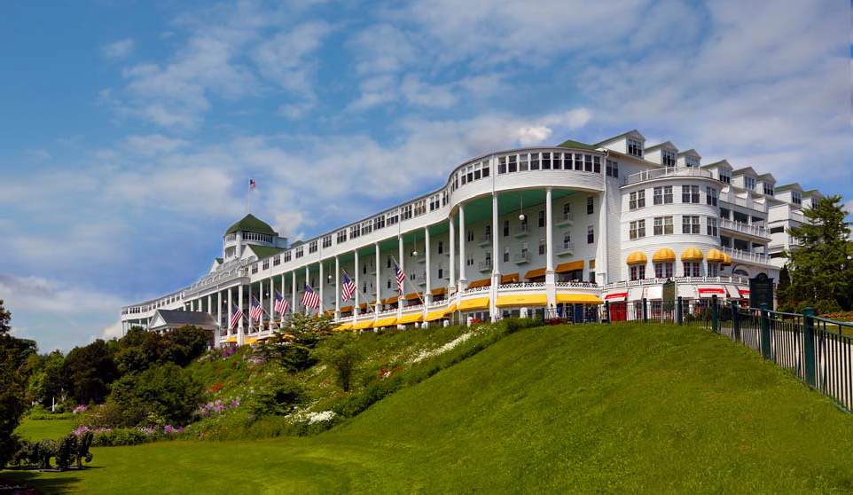

Greetings,

On behalf of Mayo Clinic School of Continuous Professional Development, we are pleased to announce the upcoming CME Course, the 2nd Annual Mayo Clinic Course on Anesthesiology Update. This course will be held July 13-15, 2018, at the Grand Hotel in Mackinac Island, Michigan. In the letter below, you will find important information regarding exhibiting at the course.

PROGRAM OVERVIEW

Anesthesiology Update will present the latest findings and recommendations for topics at the forefront of anesthesiology. Topics to include pre-operative preparation of the surgical patient, the cardiac patient in your OR, OB emergencies, neurotoxicity of anesthetics and the pediatric patient, fetal surgery concerns and post-operative care of the surgical patient. Get your CME credits at a beautiful, classic summer resort that is family friendly.

Additional information may be found at the course website at
https://ce.mayo.edu/anesthesiologyupdate2018
The fee to display at the Anesthesiology Update course is $1,500.

Exhibit Opportunity

We’ve attached Mayo’s required Exhibitor Agreement. In order to be listed as an exhibitor at this course, this signed letter must be returned to us, along with your check, by July 10, 2018. Retain one signed copy for your files and return the other along with payment (made payable to Mayo Clinic, Federal ID #41‐6011702) to Kathy Fuqua, Mayo Clinic School of Continuous Professional Development, Plummer Building 2‐60, 200 1st Street SW, Rochester, MN 55905.

We look forward to your support. If you have any questions or if there are “company‐specific” forms that need to be completed, please contact Kathy Fuqua by telephone at 507‐266‐9815 or via email at Fuqua.kathy@mayo.edu

Thank you for your consideration and we look forward to a favorable reply.

Sincerely, Vicki Meyer CME Specialist

Exhibitor Information

Overview
Anesthesiology Update will present the latest findings and recommendations for topics at the forefront of anesthesiology. Topics to include pre-operative preparation of the surgical patient, the cardiac patient in your OR, OB emergencies, neurotoxicity of anesthetics and the pediatric patient, MH updates and post-operative care of the surgical patient. Get your CME credits at a beautiful, great summer getaway and family-oriented location.

Audience
We expect 75-100 attendees at the Anesthesiology Update course. This conference is applicable to M.D.s, Ph.D.s, D.O.s, Anesthesiology Assistant (AAs), Certified Register Nurse Anesthetists (CRNAs) Residents, Fellows, NPs, PAs, Allied Health Professional and Retirees.

Attendee List
Exhibitors will be provided and attendee list with the following attendee information:
- First/Last Name
- Credentials
- City, State

Dates
Friday-Sunday, July 13-15, 2018

Website
https://ce.mayo.edu/anesthesiologyupdate2018

Location
Grand Hotel
286 Grand Avenue Mackinac Island, MI 49757

Price
$1,500, exhibit fee includes one 6 foot table and two chairs. Exhibitors are invited to participate in all food and beverage events, which include breakfast, lunch, refreshment breaks and reception. Up to two (2) company representatives may attend.

Exhibit Area
Exhibitors will be placed in the Theatre Foyer, located just outside the Theatre with the refreshments.

Set-Up
Set up will be Thursday, July 12th between 5:00–7:00 p.m.

Hours
July 13-15, 2018
From 6:30 a.m. to 12:30 p.m.

Mayo Clinic School of Continuous Professional Development (MCSCPD) Exhibitor Agreement
Agreement between: ACCREDITED PROVIDER: Mayo Clinic College of Medicine – MCSCPD AND:

Activity Title | Mayo Clinic Course on Anesthesiology Update
Activity Number | 18R05931
Location | Grand Hotel, Mackinac Island, MI
Dates | July 13-15, 2018
Company Name (Exhibitor) (as it should appear on printed materials)
Exhibit Contact (if different then exhibit Rep.)
Name(s) of Representative(s) exhibiting:
(Maximum of two representatives allowed per exhibit)
Address
Telephone
Fax
Email
Special needs (power)
The named exhibitor wishes to exhibit at the above named activity for the amount of |  |  | $1,500

TERMS AND CONDITIONS
- EXHIBITOR agrees to abide by ACCME Standards for Commercial Support as stated at www.accme.org: SCS 4.2: “Product-promotion material or product-specific advertisement of any type is prohibited in or during CME activities. The juxtaposition of editorial and advertising material on the same products or subjects must be avoided. Live (staffed exhibits, presentations) or enduring (printed or electronic advertisements) promotional activities must be kept separate from CME.” “For live, face-to-face CME, advertisements and promotional materials cannot be displayed or distributed in the educational space immediately before, during or after a CME activity. Providers cannot allow representatives of Commercial Interests to engage in sales or promotional activities while in the space or place of the CME activity.”
- EXHIBITOR may only distribute educational promotional materials at their exhibit space. Distribution of non-educational items (pens, notepads, etc.), pharmaceuticals or product samples is prohibited.
- All exhibit fees associated with this activity will be given with the full knowledge of the PROVIDER. No additional payments, goods, services or events will be provided to the course director(s), planning committee members, faculty, joint provider, or any other party involved with the activity.

  - Completion of this agreement represents a commitment and payment is due and collectible by the ACTIVITY DATE unless otherwise agreed upon by the PROVIDER. PROVIDER reserves the right to refuse exhibit space to EXHIBITOR in the event of nonpayment or Code of Conduct violation.
  - PROVIDER agrees to provide exhibit space and may acknowledge EXHIBITOR in activity announcements. PROVIDER reserves the right to assign exhibit space or relocate exhibits at its discretion.

By signing below, I agree to the “Terms and Conditions” outlined on Page 1 of this Exhibitor Agreement (including ACCME Standards for Commercial Support):
The person signing below is authorized to enter into this agreement:
Exhibitor Representative Name | Signature | Date
Mayo Clinic Representative Name | Signature | Date

PAYMENT INFORMATION
Please indicate your method of payment:

PROVIDER Federal Tax ID number is 41-6011702.
Please remit check payable to: Mayo Clinic- Mayo Clinic School of CPD. Please identify name of course on the check stub.

□ Check | □ Credit Card or Wire Transfer
Make payable to: | For payment by credit card or wire transfer, please call
Mayo Clinic | the MCSCPD Registrar at 800‐323‐2688
Mayo Clinic School of Continuous Professional
Development | Do not send credit card information via email or fax.
200 First St SW, Plummer 2‐60
Rochester, MN 55905
Please identify the Anesthesiology Update course
on the check.

