**9th Annual**

**Hospital Medicine for NPs & PAs**

Mayo Civic Center

300 Civic Center Drive SE

Rochester, MN

May 10-12, 2017

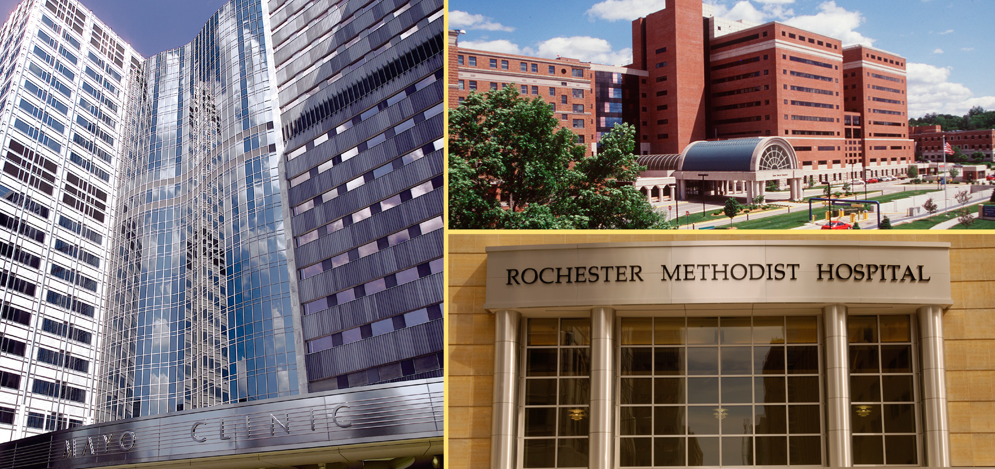

Greetings,

On behalf of Mayo Clinic School of Continuous Professional Development, we are pleased to announce upcoming CME Course, the ***9th Annual*** ***Hospital Medicine for NPs & PAs.*** This course willbe held May 10-12, 2017, at the Mayo Civic Center in Rochester, Minnesota. In the letter below, you will find important information regarding exhibiting at the course.

**Program Overview**

NPs and PAs are finding themselves at the forefront of caring for the vastly growing hospitalized patient population. The 9th Annual Hospital Medicine for NPs and PAs course is designed to provide NP and PA hospitalists with up to date, evidence-based information and resources on the care of complex hospitalized patients. This course is specifically geared toward NPs and PAs as well as advanced practice nurses, registered nurses and other health care providers who care for hospitalized patients.

Additional information may be found at the [course website](https://ce.mayo.edu/nppahospital2017). The fee to display at the Hospital Medicine for NPs & PAs course is $2,000.

**Exhibit Opportunity**

We’ve attached Mayo’s required **Exhibitor Agreement**. In order to be listed as an exhibitor at this

course, this signed letter must be returned to us, along with your check, by May 1, 2017. Retain one signed copy for your files and return the other along with payment (made payable to Mayo Clinic, Federal ID #41-6011702) to Kathy Fuqua, Mayo Clinic School of Continuous Professional Development, Plummer Building 2-60, 200 1st Street SW, Rochester, MN 55905.

We look forward to your support. If you have any questions or if there are “company-specific” forms

that need to be completed, please contact [Kathy Fuqua](mailto:Fuqua.kathy@mayo.edu) by telephone at 507-266-9815.

Thank you for your consideration and we look forward to a favorable reply.

Sincerely,

Vicki Meyer

CME Specialist

**Exhibitor Information**

**Overview**

NPs and PAs are finding themselves at the forefront of caring for the vastly growing hospitalized patient population. The 9th Annual Hospital Medicine for NPs and PAs course is designed to provide NP and PA hospitalists with up to date, evidence-based information and resources on the care of complex hospitalized patients. This course is specifically geared toward NPs and PAs as well as advanced practice nurses, registered nurses and other health care providers who care for hospitalized patients.

**Audience**

# We expect 200 attendees at the Hospital Medicine for NPs & PAs course. This conference is applicable to internists, hospitalists, nurse practitioners, physician assistants, advanced practice nurses, registered nurses and allied health from novice to experienced.

**Dates**

Wednesday-Friday, May 10-12, 2017

**Course Highlights**

* 20.0 *AMA PRA Category 1 Credits*™
* Approximately 6.75 hours of pharmacology content
* Optional Skills Workshop-7.25 *AMA PRA Category 1 Credits*™
* Optional Pharmacology Workshop-4.0 *AMA PRA Category 1 Credits*™
* Course Reception

• Welcome Networking Reception

[**Website**](https://ce.mayo.edu/nppahospital2017)

**Location**

Mayo Civic Center

300 Civic Center Drive SE

Rochester, MN 55904

**Price**

$2,000, exhibit fee includes one 6 foot table and two chairs. Exhibitors are invited to participate in all food and beverage events, which include breakfast, lunch, refreshment breaks and reception. Up to two (2) company representatives may attend.

**Exhibit Area**

Exhibitors will be placed in the Foyer, located just outside the main meeting room with the refreshments.

**Set-Up**

Set up will be Tuesday, May 9th between 3:00–7:00 p.m.

**Hours**

Wednesday, May 10, 2017 7:00 a.m. to Friday, May 12, 2017, 4:00 p.m.

# Mayo Clinic School of Continuous Professional Development (MCSCPD) Exhibitor Agreement

|  |  |
| --- | --- |
| Activity Title | 9th Annual Hospital Medicine for NPs & PAs |
| Activity Number | 17R04776 |
| Location | Mayo Civic Center, Rochester, MN |
| Dates | May 10-12, 2017 |

Agreement between: ACCREDITED PROVIDER: Mayo Clinic College of

Medicine – MCSCPD AND:

|  |  |  |
| --- | --- | --- |
| Company Name (Exhibitor)  (as it should appear on printed materials) |  | |
| Exhibit Contact (if different then exhibit Rep.) |  | |
| Name(s) of Representative(s) exhibiting:  (Maximum of two representatives allowed per exhibit) |  | |
| Address |  | |
| Telephone |  | |
| Fax |  | |
| Email |  | |
| Special needs (power) |  | |
| The named exhibitor wishes to exhibit at the above named activity for the amount of | | $2,000 |

*TERMS AND CONDITIONS*

* EXHIBITOR agrees to abide by ACCME Standards for Commercial Support as stated at [www.accme.org](http://www.accme.org): SCS 4.2: “Product-promotion material or product-specific advertisement of any type is prohibited in or during CME activities. The juxtaposition of editorial and advertising material on the same products or subjects must be avoided. Live (staffed exhibits, presentations) or enduring (printed or electronic advertisements) promotional activities must be kept separate from CME.” “For live, face-to-face CME, advertisements and promotional materials cannot be displayed or distributed in the educational space immediately before, during or after a CME activity. **Providers cannot allow representatives of Commercial Interests to engage in sales or promotional activities while in the space or place of the CME activity.”**
* EXHIBITOR may only distribute educational promotional materials at their exhibit space. Distribution of non-educational items (pens, notepads, etc.), pharmaceuticalsor product samples is prohibited.
* All exhibit fees associated with this activity will be given with the full knowledge of the PROVIDER. No additional payments, goods, services or events will be provided to the course director(s), planning committee members, faculty, joint provider, or any other party involved with the activity.
* Completion of this agreement represents a commitment and payment is due and collectible by the ACTIVITY DATE unless otherwise agreed upon by the PROVIDER. PROVIDER reserves the right to refuse exhibit space to EXHIBITOR in the event of nonpayment or Code of Conduct violation.
* PROVIDER agrees to provide exhibit space and mayacknowledge EXHIBITOR in activity announcements. PROVIDER reserves the right to assign exhibit space or relocate exhibits at its discretion.

**By signing below, I agree to the “Terms and Conditions” outlined on Page 1 of this Exhibitor Agreement (including ACCME Standards for Commercial Support):**

The person signing below is authorized to enter into this agreement:

|  |  |  |
| --- | --- | --- |
| Exhibitor Representative Name | Signature | Date |
|  |  |  |
| Mayo Clinic Representative Name | Signature | Date |
|  |  |  |

*PAYMENT INFORMATION*

Please indicate your method of payment:

PROVIDER **Federal Tax ID number is 41-6011702**.  
Please remit check payable to: Mayo Clinic- Mayo Clinic School of CPD.

Please identify name of course on the check stub.

|  |  |
| --- | --- |
| Check | Credit Card or Wire Transfer |
| Make payable to: Mayo Clinic  Mayo Clinic School of Continuous Professional Development  200 First St SW, Plummer 2-60  Rochester, MN 55905  Please identify **Hospital Medicine NPs & PAs** on the check. | For payment by credit card or wire transfer, please call the MCSCPD Registrar at 800-323-2688  *Do not send credit card information via email or fax.* |