Mayo Clinic Course on

Shoulder Tendon Transfers and Complex Rotator Cuff Repair

Mayo Clinic Campus
Siebens Medical Education Building
100 2nd Avenue SW
Rochester, MN

April 25-26, 2019

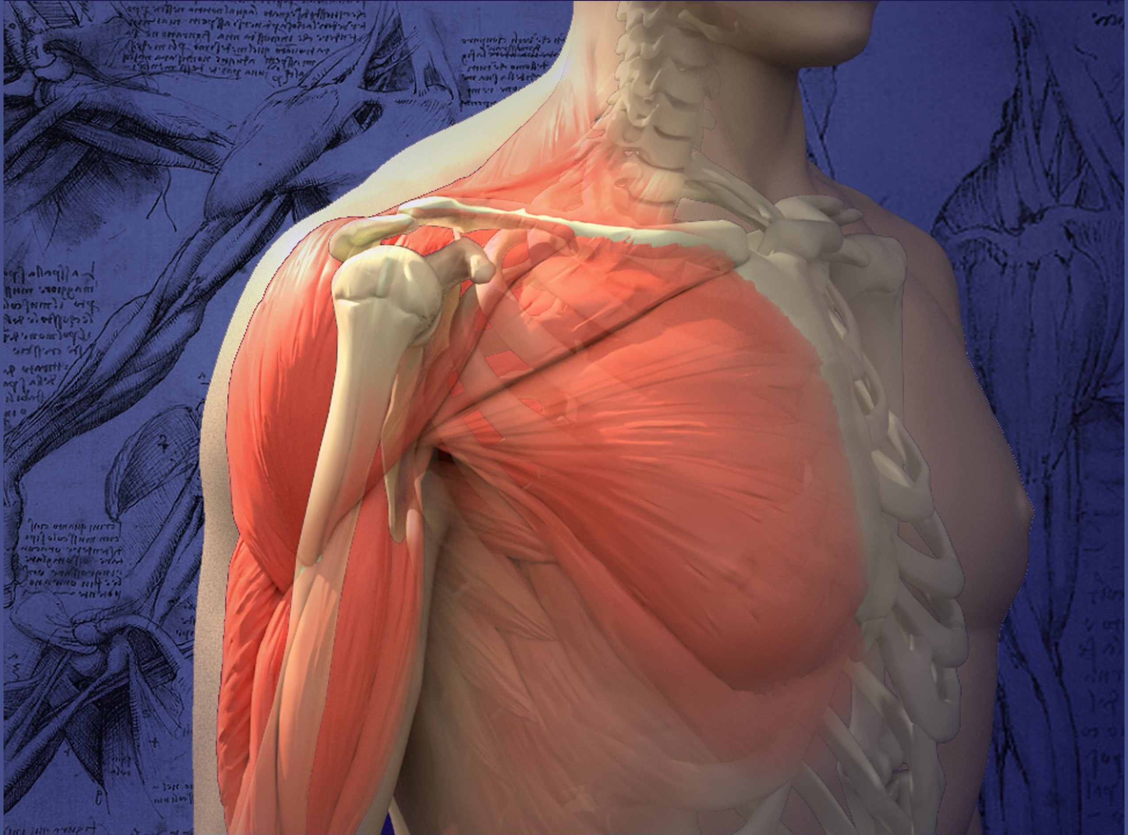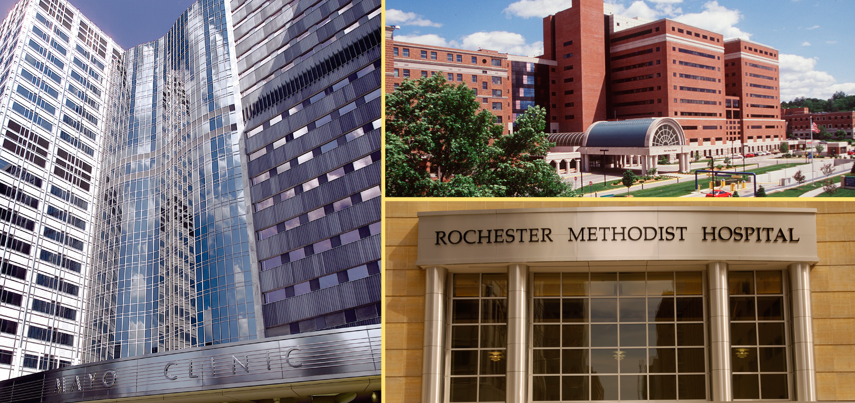

Greetings,

On behalf of Mayo Clinic School of Continuous Professional Development, we are pleased to announce the upcoming CME Course, the Mayo Clinic Course on Shoulder Tendon Transfers and Complex Rotator Cuff Repair. This course will be held April 25-26, 2019, at the Mayo Clinic in Rochester, Minnesota. In the letter below, you will find important information regarding exhibiting at the course.

Program Overview
This course will provide cutting-edge presentations, cadaver demonstrations, and cadaver-based workshops on the management of complex rotator cuff tears and conditions affecting the scapulothoracic joint. The course will highlight the principles, surgical techniques and outcomes of tendon transfers around the shoulder joint and scapula, advanced arthroscopically-assisted tendon transfers, and alternative salvage procedures such as reconstruction of the superior capsule, reverse shoulder arthroplasty and shoulder/scapulothoracic fusion. A portion of the course will allow attendees to perform tendon transfers on whole torso and upper extremity cadaveric specimens.

Additional information may be found at the course website at https://ce.mayo.edu/shoulder2019
The fee to display at the Shoulder Tendon Transfer and Complex Rotator Cuff Repair course is $1,500.

Exhibit Opportunity
We’ve attached Mayo’s required Exhibitor Agreement. In order to be listed as an exhibitor at this
course, this signed letter must be returned to us, along with your check, by April 20, 2019. Retain one signed copy for your files and return the other along with payment (made payable to Mayo Clinic, Federal ID #41-6011702) to Kathy Fuqua, Mayo Clinic School of Continuous Professional Development, Plummer Building 2-60, 200 1st Street SW, Rochester, MN 55905.

We look forward to your support. If you have any questions or if there are “company-specific” forms
that need to be completed, please contact Kathy Fuqua by telephone at 507-266-9815 or via email
at Fuqua.kathy@mayo.edu

Thank you for your consideration and we look forward to a favorable reply.

Sincerely,
Vicki Meyer
CME Specialist
Exhibitor Information

Overview
This course will provide cutting-edge presentations, cadaver demonstrations, and cadaver-based workshops on the management of complex rotator cuff tears and conditions affecting the scapulothoracic joint. The course will highlight the principles, surgical techniques and outcomes of tendon transfers around the shoulder joint and scapula, advanced arthroscopically-assisted tendon transfers, and alternative salvage procedures such as reconstruction of the superior capsule, reverse shoulder arthroplasty and shoulder/scapulothoracic fusion.

Audience

We expect 120 attendees at the Shoulder Tendon Transfer and Complex Cuff Repair course. This conference is applicable to Orthopedic Surgeons.

Dates
Thursday-Friday, April 25-26, 2019

Course Highlights
- Focus on shoulder tendon transfers and complex cuff reconstruction
- World-renowned national and international faculty
- Cadaver lab using a whole torso with both upper extremities
- One-on-one faculty to attendee interaction during the cadaver lab
- Sessions dedicated to interactive, case discussions with faculty
- Optional Cadaver Workshop-April 27th (No exhibit space is available at the workshop)

Website
https://ce.mayo.edu/shoulder2019

Location
Mayo Clinic
Siebens Medical Education Building
Leighton Auditorium, 2nd Floor
100 2nd Avenue SW
Rochester, MN 55905

Price
$1,500, exhibit fee includes one 6 foot table and two chairs. Exhibitors are invited to participate in all food and beverage events, which include breakfast, lunch, refreshment breaks and reception. Up to two (2) company representatives may attend.

Exhibit Area
Exhibitors will be in the Foyer, located just outside the Rochester Marriott Ballroom with the refreshments.

Set-Up
Set up will be Wednesday, April 24th between 3:00–7:00 p.m.

Hours
April 25th and 26th 6:00 a.m. to 6:15 p.m.

Mayo Clinic School of Continuous Professional Development (MCSCPD)
Exhibitor Agreement

Activity Title | Mayo Clinic Course on Shoulder Tendon Transfers and Complex Rotator Cuff Repair
Activity Number | 19R05937
Location | Mayo Clinic, Siebens Building, Rochester, MN
Dates | April 25-26, 2019
Agreement between: ACCREDITED PROVIDER: Mayo Clinic College of
Medicine – MCSCPD AND:
Company Name (Exhibitor)
(as it should appear on printed materials)
Exhibit Contact (if different then exhibit Rep.)
Name(s) of Representative(s) exhibiting:
(Maximum of two representatives allowed per exhibit)
Address
Telephone
Fax
Email
Special needs (power, dietary)
The named exhibitor wishes to exhibit at the above named activity for the amount of |  | $1,500

TERMS AND CONDITIONS
- EXHIBITOR agrees to abide by ACCME Standards for Commercial Support as stated at www.accme.org: SCS 4.2: “Product-promotion material or product-specific advertisement of any type is prohibited in or during CME activities. The juxtaposition of editorial and advertising material on the same products or subjects must be avoided. Live (staffed exhibits, presentations) or enduring (printed or electronic advertisements) promotional activities must be kept separate from CME.” “For live, face-to-face CME, advertisements and promotional materials cannot be displayed or distributed in the educational space immediately before, during or after a CME activity. Providers cannot allow representatives of Commercial Interests to engage in sales or promotional activities while in the space or place of the CME activity.”
- EXHIBITOR may only distribute educational promotional materials at their exhibit space. Distribution of non-educational items (pens, notepads, etc.), pharmaceuticals or product samples is prohibited.
- All exhibit fees associated with this activity will be given with the full knowledge of the PROVIDER. No additional payments, goods, services or events will be provided to the course director(s), planning committee members, faculty, joint provider, or any other party involved with the activity.

- Completion of this agreement represents a commitment and payment is due and collectible by the ACTIVITY DATE unless otherwise agreed upon by the PROVIDER. PROVIDER reserves the right to refuse exhibit space to EXHIBITOR in the event of nonpayment or Code of Conduct violation.
- PROVIDER agrees to provide exhibit space and may acknowledge EXHIBITOR in activity announcements. PROVIDER reserves the right to assign exhibit space or relocate exhibits at its discretion.

By signing below, I agree to the “Terms and Conditions” outlined on Page 1 of this Exhibitor Agreement (including ACCME Standards for Commercial Support):
The person signing below is authorized to enter into this agreement:
Exhibitor Representative Name | Signature | Date
Mayo Clinic Representative Name | Signature | Date

PAYMENT INFORMATION
Please indicate your method of payment:

PROVIDER Federal Tax ID number is 41-6011702.
Please remit check payable to: Mayo Clinic- Mayo Clinic School of CPD.
Please identify name of course on the check stub.

☐ Check | ☐ Credit Card or Wire Transfer
Make payable to:  Mayo Clinic  Mayo Clinic School of Continuous Professional Development  200 First St SW, Plummer 2-60  Rochester, MN 55905  Please identify the Shoulder Tendon Transfer course on the check. | For payment by credit card or wire transfer, please call the MCSCPD Registrar at 800-323-2688  Do not send credit card information via email or fax.

