
3rd Annual ASBMT Regional Conference
for NPs, PAs and Fellows
featuring “Best of Tandem 2016”

Lowes Minneapolis Hotel, Minneapolis, MN
Thursday-Saturday, October 13-15, 2016

Jointly planned by the American Society for Blood and Marrow Transplantation
and the National Marrow Donor Program©/Be The Match©.
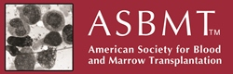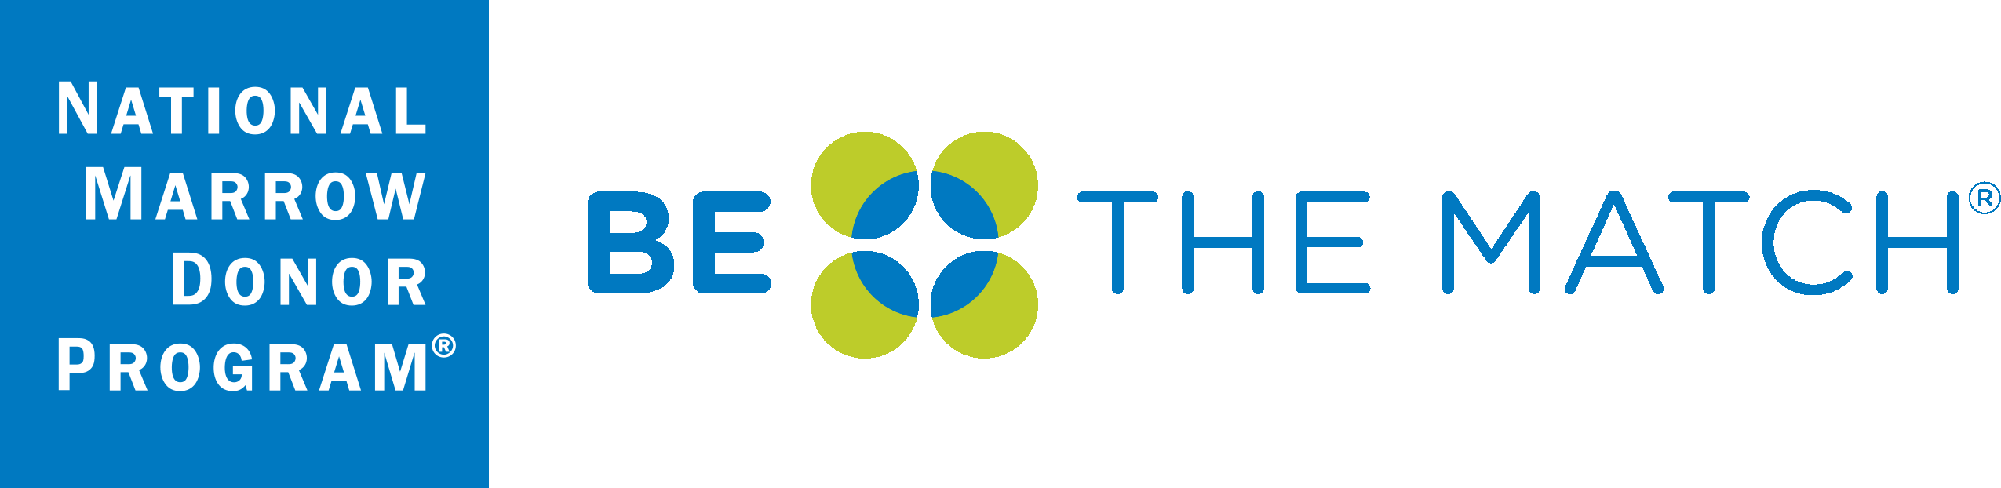
Exhibit Opportunities

Dear Potential Exhibitor,

On behalf of course directors Amy Witter, P.A.-C. and Brenda Frye, P.A.-C. and the Mayo School of Continuous Professional Development, we are pleased to announce our upcoming 3rd Annual ASBMT Regional Conference for NPs, PAs and Fellows featuring “Best of Tandem 2016”, to be held October 13-15, 2016, at the Lowes Minneapolis Hotel in Minneapolis, Minnesota.

This two and a half day CME program will update NPs, PAs, fellows, and junior faculty on key findings presented at the annual BMT Tandem Meeting, as well as other timely and highly relevant research and clinical care topics in the field of blood and marrow transplantation.

We anticipate 200 attendees at this year’s course. Additional course details can be found on the course web site as they become available: https://ce.mayo.edu/node/15425

Mayo Clinic recognizes these types of educational programs would not be possible without your support. We invite you to participate at this educational activity with an exhibit in the amount of $1,500. This fee is for the exhibit space only. Industry exhibitors are provided a draped table with two chairs. In support of ACCME guidelines, exhibitors will be located in a separate area from the educational activity. Exhibit space is limited and located near the food and beverage area for optimal contact during breakfast, breaks, and lunch.

To exhibit at this course:
- Complete and return the provided Exhibitor Agreement form. This agreement may be substituted with your company’s standard Letter of Agreement form.
- Submit payment before October 1, 2016. Please make payment payable to Mayo Clinic and send payment to my attention at the address below. For your convenience, our Federal tax identification number is 41-6011702.

We look forward to the success of the 3rd Annual ASBMT Regional Conference for NPs, PAs and Fellows,
featuring “Best of Tandem 2016” and hope you will be able to join us in Minneapolis, Minnesota this coming October. If you have any questions or your company requires completion of a web-based application, please feel free to contact me.

Sincerely,

Kathy Fuqua
Education Administration Coordinator
Mayo School of Continuous Professional Development
200 First Street SW
Rochester, MN 55905
Fuqua.kathy@mayo.edu
Phone: 507-266-9815

Attachments: Program Schedule
W-9

Exhibitor Information

Overview
The Blood and Marrow Transplant Conference for NPs, PAs and fellows provides lecture and case-based presentations by specialists in the field who will discuss current treatment challenges faced by clinicians involved in the care of both adult and pediatric transplant patients. The conference will also feature ample opportunity for interactive discussion and question/answer sessions.

Audience
We expect 200 attendees at the Blood and Marrow Transplant Conference. This course was designed with Nurse Practitioners, Physician Assistants and Fellows in mind.

Dates
Thursday-Saturday
October 13-15, 2016

Course Highlights
- Case Based lectures designed for interactive audience discussion
- “Best of Tandem” Presentation
- Best Practices and Networking Discussion
- Pediatric Breakout Session
- Welcome Networking Reception

• Welcome Networking Reception
Website
https://ce.mayo.edu/node/15245

Location
Loews Minneapolis Hotel
601 1st Avenue North
Minneapolis, MN 55403
Price
$1,500, exhibit fee includes one 6 foot table and two chairs. Exhibitors are invited to participate in all food and beverage events, which include breakfast, lunch and refreshment breaks. Up to two (2) company representatives may attend.
Exhibit Area
Exhibitors will be placed in the Ballroom Foyer, located just outside the main meeting room with the refreshments.

Set-Up
Set up will be Thursday, October 13 between 10:00–11:00 a.m.
Hours
Thursday, October 13, 11:30 a.m. to Saturday, October 15, 2016, 3:00 p.m.

Registration Link

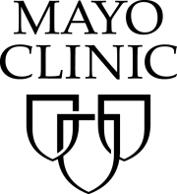
Mayo School of Continuous Professional Development (MSCPD)
Exhibitor Agreement
Activity Title | Blood and Marrow Transplant Conference
Activity Number | 2016R351
Location | Loews Minneapolis Hotel, Minneapolis, MN
Dates | Thursday-Saturday, October 13-15, 2016

Agreement between: ACCREDITED PROVIDER: Mayo Clinic College of Medicine – MSCPD AND:
Company Name (Exhibitor)
(as it should appear on printed materials)
Exhibit Contact (if different then exhibit Rep.)
Name(s) of Representative(s) exhibiting:
(Maximum of two representatives allowed per exhibit)
Address
Telephone
Fax
Email
The named exhibitor wishes to exhibit at the above named activity for the amount of |  | $1,500
TERMS AND CONDITIONS
- EXHIBITOR agrees to abide by ACCME Standards for Commercial Support as stated at www.accme.org: SCS 4.2: “Product-promotion material or product-specific advertisement of any type is prohibited in or during CME activities. The juxtaposition of editorial and advertising material on the same products or subjects must be avoided. Live (staffed exhibits, presentations) or enduring (printed or electronic advertisements) promotional activities must be kept separate from CME.” “For live, face-to-face CME, advertisements and promotional materials cannot be displayed or distributed in the educational space immediately before, during or after a CME activity. Providers cannot allow representatives of Commercial Interests to engage in sales or promotional activities while in the space or place of the CME activity.”
- EXHIBITOR may only distribute educational promotional materials at their exhibit space. Distribution of non-educational items (pens, notepads, etc.), pharmaceuticals or product samples is prohibited.
- All exhibit fees associated with this activity will be given with the full knowledge of the PROVIDER. No additional payments, goods, services or events will be provided to the course director(s), planning committee members, faculty, joint provider, or any other party involved with the activity.
- Completion of this agreement represents a commitment and payment is due and collectible by the ACTIVITY DATE unless otherwise agreed upon by the PROVIDER. PROVIDER reserves the right to refuse exhibit space to EXHIBITOR in the event of nonpayment or Code of Conduct violation.
- PROVIDER agrees to provide exhibit space and may acknowledge EXHIBITOR in activity announcements. PROVIDER reserves the right to assign exhibit space or relocate exhibits at its discretion.
By signing below, I agree to the “Terms and Conditions” outlined on Page 1 of this Exhibitor Agreement (including ACCME Standards for Commercial Support):
The person signing below is authorized to enter into this agreement:
Exhibitor Representative Name | Signature | Date
Mayo Clinic Representative Name | Signature | Date

PAYMENT INFORMATION
Please indicate your method of payment:

PROVIDER Federal Tax ID number is 41-6011702.
Please remit check payable to: Mayo Clinic- Mayo School of CPD. Please identify name of course on the check stub.

☐ Check | ☐ Credit Card or Wire Transfer
Make payable to:  Mayo Clinic  Mayo School of Continuous Professional Development  200 First St SW, Plummer 2-60  Rochester, MN 55905  Please identify Blood and Marrow Transplant (BMT) on the check. | For payment by credit card or wire transfer, please call the MSCPD Registrar at 800-323-2688  Do not send credit card information via email or fax.

NOTE: There may be additional charges depending on the meeting location (power, internet access, etc).
Please list additional requests here:

Complete and return this form along with your payment made to Mayo Clinic,
Federal Tax ID# 41-6011702 before October 1, 2016 to:
Vicki Meyer/Kathy Fuqua
200 First St SW, Plummer 2-60
Rochester, MN 55905
T: 507-266-7992 F: 507-266-9815 E: Fuqua.kathy@mayo.edu

