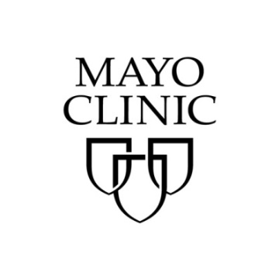

John D. Halamka, M.D., M.S

John D. Halamka, M.D., M.S., president of the Mayo Clinic Platform, leads a portfolio of platform businesses focused on transforming healthcare by leveraging artificial intelligence, connected health care devices and a network of trusted partners.

Trained in emergency medicine and medical informatics, Dr. Halamka has been developing and implementing health care information strategy and policy for more than 25 years.

Prior to his appointment at Mayo Clinic, Dr. Halamka was chief information officer at Beth Israel Deaconess Medical Center and Harvard Medical School. He is a practicing emergency medicine physician. As the International Healthcare Innovation Professor at Harvard
Medical School, Dr. Halamka helped the George W. Bush administration, the Obama administration and governments around the world plan their health care information strategies.

Dr. Halamka completed his undergraduate studies at Stanford University, earned his medical degree at the University of California, San Francisco, and pursued graduate work in bioengineering at the University of California, Berkeley. He completed his residency at UCLA-Harbor Medical Center in the Department of Emergency Medicine. He is a member of the National Academy of Medicine

Dr. Halamka has written a dozen books about technology-related issues, hundreds of articles and thousands of posts on the Geekdoctor blog. He also runs Unity Farm Sanctuary in Sherborn, Massachusetts, the largest animal sanctuary in New England.

