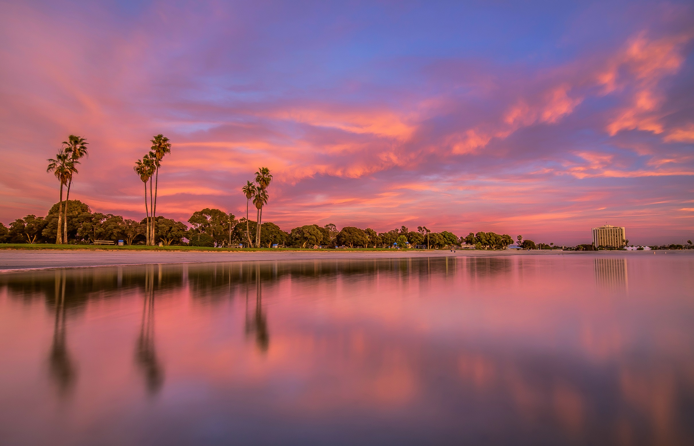
EXHIBITOR PROSPECTUS
Mayo Clinic School of Continuous Professional Development

10th Annual Hospital Medicine for Nurse Practitioners and Physicians Assistants
June 20-23, 2018
Hyatt Regency Mission Bay Spa & Marina, San Diego, CA
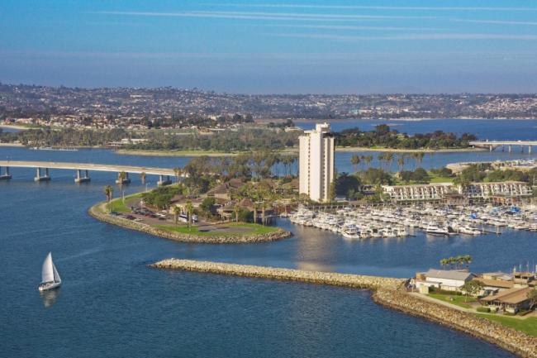

10th Annual Hospital Medicine
for NPs & PAs
Acte Care of the Complex Hospitalized Patient
for NPs & PAs

CONTENTS
Welcome 3
Dates 4
Planning Committee
& Key Contacts 4
Conference Highlights 5
Exhibitor Information 6
Sponsorship Opportunities 6
Exhibit Hall Floor Plan 8
Rules and Regulations 9
Hotel Accommodations 10

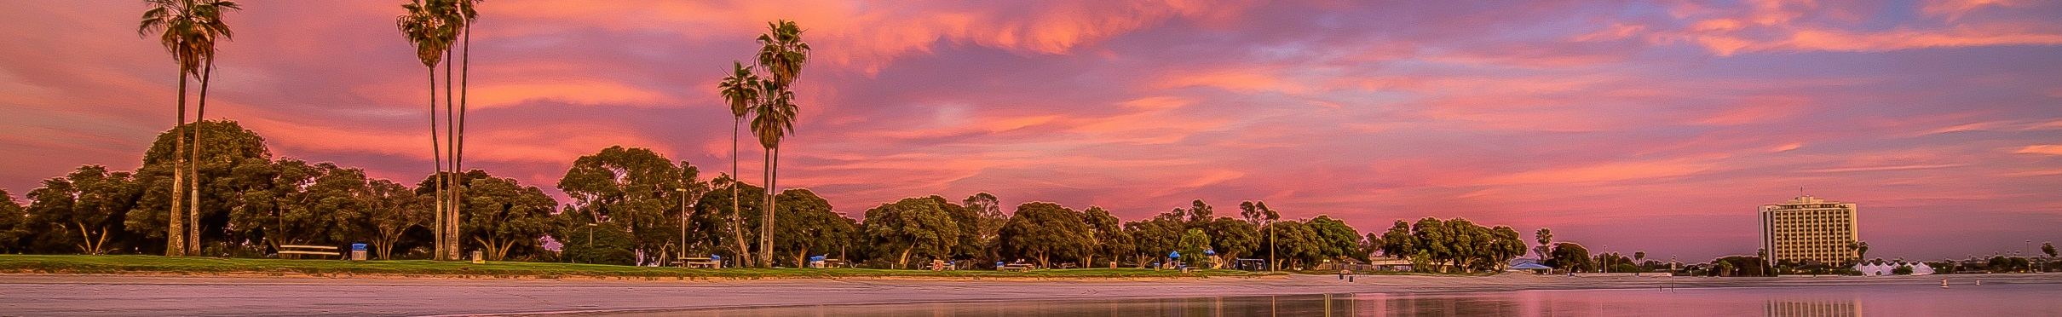

Welcome

Dear Exhibitors,
On behalf of the Mayo Clinic School of Continuous Professional Development, I am pleased to invite you to participate in the 10th Annual Mayo Clinic Hospital Medicine for NPs & PAs that will take place on June 20-23, 2018 at the Hyatt Regency Mission Bay Spa & Marina in San Diego, California.

Hospital care models are transforming, and nurse practitioners and physician assistants play vital roles in the care delivery of hospitalized patients. Hospital Medicine for NPs & PAs fills your CME needs. This conference emphasizes clinical management of hospitalized patients in an interactive, case-based format with evidence-based lectures by experts in treatment pathways from admission to discharge.

Course Highlights

- 25.25 AMA PRA Category 1 CreditTM
- 25.25 ANCC Credits
- Approximately 10.5 hours of pharmacology content
- Pharmacology Workshop
- Critical Care Breakout
- Contemporary guideline-based best practices
- Clinical care pathways
- Diagnostic and treatment algorithms
- Common clinical dilemmas
- Practicing health care provider faculty

We anticipate 350 attendees at the program. We have 30 faculty members who are practicing clinicians. To view the entire program and additional information please go to https://ce.mayo.edu/nppahospital2018
Sincerely,
CME Course Co-Directors

James Newman, M.D., M.S. | Andrew Herber, P.A.-C. | S. Ahsan Rizvi, M. D.
Assistant Professor of History | Assistant Professor of Medicine | Assistant Professor of Medicine
Of Medicine Hospital Internal Medicine  Hospital Internal Medicine |  |  |  | Hospital Internal Medicine

Dates & Location
Meeting Dates:
Wednesday, June 20, 2018 through Friday, June 23, 2018
Meeting Location:

Hyatt Regency Mission Bay Spa & Marina
1441 Quivira Road
San Diego, CA 92109
Tel: +1 619 224 1234
https://missionbay.regency.hyatt.com/en/hotel/home.html
Course Website:
https://ce.mayo.edu/nppahospital2018

Committee Members and Key Contacts

Committee Members
James Newman, M.D., M.S.  Associate Professor of Medicine, Assistant Professor of History of Medicine  Hospital Internal Medicine | Andrew Herber, P.A.-C.  Assistant Professor of Medicine  Hospital Internal Medicine | S. Ahsan Rizvi, M.D.  Assistant Professor of Medicine  Hospital Internal Medicine
Key Contacts
Vicki R. Meyer, B.S.  CME Specialist  Ph: 507-266-7992  Meyer.vicki@mayo.edu | Kathy Fuqua  CME Education Specialist  Ph: 507-266-9815  Fuqua.kathy@mayo.edu

Conference Highlights Topics and speakers are carefully chosen to provide quality, practical and evidence-based workshops and plenary sessions.

Presentation Topics for 2018 include:

- KEYNOTE: Jamie & Andy’s Excellent Adventure: 10 Years of NPPA Education
- Updates in Hospital Medicine
- Inpatient Psychiatry
- Nephrology Consults
- Critical Care Updates
- Drugs of Abuse
- Stroke
- Heart Failure Management
- Infectious Disease Updates
- Geriatric Updates
- Perioperative Medicine Pearls
- Hospital Cases of VTE
- Hospitalist NPPA Updates
- Sepsis
- Hospital Diabetes
- Cases in Telemetry
- Antibiotic Updates
- GI Bleeds
- Acute Abdomen
- Hospital Diarrhea
- Hematology Consults
- Lab Rats to the Rescue
- Palliative Care Pearls

Presentation Topics for Critical Care Breakout include:

- The Difficult Airway
- Mechanical Ventilation
- Antibiotic Selection in the Era of Emerging Resistance
- Diagnosing Shock and Managing Vasopressors
- Case Studies in Codes

Presentation Topics for Pharmacology Workshop include:

- Novel Anticoagulants
- Geriatric Polypharmacy
- Inpatient Pain Management
- Immunosuppressed Patients

Why Exhibit?
Technical and educational exhibits provide a professional and educational environment in which NPs, PAs, APNs, RNs, and physicians can receive demonstrations, view products and services and discuss the clinical and surgical uses of these products and services, including how they may improve the quality of care and the management of the medical/surgical practice. Additionally, the exhibits enhance the educational content of the meeting helping to provide quality continuing medical education.

Benefits:
  - Interact face-to-face with influential decision makers in the field of hospital internal medicine
  - Build visibility for your company in a competitive marketplace
  - Expand your customer base and strengthen existing customer relationships
  - Introduce new products and services
  - Additional advertisement opportunities to expand reach and further socialize with attendees

General Exhibitor Information Exhibit Hours Schedule
EXHIBIT CONTACT: Tuesday, June 19, 2018
Exhibitor Set-Up 5:00 PM – 7:00 PM
Kathy Fuqua

Mayo Clinic School of Continuous Professional Development Wednesday, June 20, 2018 6:30 a.m. – 11:45 p.m.
Plummer 2-60, 200 1st ST SW, Rochester, MN 55905 Thursday, June 21, 2018 7:00 a.m. – 3:30 p.m.
Ph: 507-266-9185 Friday, June 22, 2018 7:00 a.m. – 12:15 p.m.
Fax: 507-538-7234 Saturday, June 23, 2018 7:00 a.m. – 12:30 p.m.
Exhibitor Tear Down 12:45 p.m. – 1:00 p.m.
Booth Fee: $2,000
  - (1) 8’ table (2) chairs
  - Location preference
  - General maintenance of the common areas of the exhibit hall
  - Access to networking opportunities throughout the conference

Exhibitor Assignments
Every effort will be made to give exhibitors their first choice of location. In case of conflicting requests, priority will be determined on the basis of: 1) Amount of space requested, 2) Date the application was received by MCSCPD, 3) Special needs of the exhibitors. Booth assignments will be made when full payment is received and these SOLD booths will be updated on the Exhibitor Prospectus.

Additional Advertisement Opportunities

Hotel Key Card-$5,000.00 (Exclusive) - Personalize hotel guest room keys with your company’s logo or product promotion for immediate exposure to attendees. Use this as a great way to introduce yourselves to our attendees upon checking into the host hotel. Include your booth number to remind them where you’ll be throughout the conference. (Artwork to be provided by sponsoring company by June 1, 2018)

Internet- $5,000.00 (Exclusive) - Help attendees stay connected with their office and home while away at the Hospital Medicine for NPs & PAs course. The supporter will be recognized throughout the meeting in signage and electronic communications.

Attendee lanyards logo-$5,000.00 (Exclusive) - Personalize lanyards with your company’s logo or product promotion for immediate exposure to attendees.
Conference Bags- $2,500 - Personalize conference bags with your company’s logo or product promotion for immediate exposure to attendees. Use this as a great way to introduce yourselves to our attendees upon checking into the course. Include your booth number to remind them where you’ll be throughout the conference. (Artwork to be provided by sponsoring company by June 1, 2018)

Conference Bag Inserts- $1,500.00 - Conference bag inserts are a great opportunity to invite attendees to your booth, announce your booth participation or conference- related event. Your company will provide 400 copies of the flyer or advertisement (no larger than 8 ½ x 11, no more than one page) and MCSCPD will stuff them into the official conference bags. Artwork is subject to MCSCPD approval.

Platinum Sponsorship A (exclusive)- $10,000
Hotel key card logo - Personalize hotel guest room keys with your company’s logo or product promotion for immediate exposure to attendees.*
Conference bag logo - Personalize conference bags with your company’s logo or product promotion for immediate exposure to attendees.*
Conference bag inserts - Your company will provide 400 copies of the flyer or advertisement (no larger than 8 ½ x 11, no more than one page) and MCSCPD will stuff them into the official conference bags.
Registration at the course for 2 exhibitors.
Exhibitor Table

Platinum Sponsorship B (exclusive) - $10,000
Attendee lanyards logo - Personalize lanyards with your company’s logo or product promotion for immediate exposure to attendees.*
Conference bag logo - Personalize conference bags with your company’s logo or product promotion for immediate exposure to attendees.*
Conference bag inserts - Your company will provide 400 copies of the flyer or advertisement (no larger than 8 ½ x 11, no more than one page) and MCSCPD will stuff them into the official conference bags.
Registration at the course for 2 exhibitors.
Exhibitor Table

Platinum Sponsorship C (exclusive) - $10,000
Internet- Sponsor the wireless internet access in the meeting space
Conference bag logo - Personalize conference bags with your company’s logo or product promotion for immediate exposure to attendees.*
Conference bag inserts - Your company will provide 400 copies of the flyer or advertisement (no larger than 8 ½ x 11, no more than one page) and MCSCPD will stuff them into the official conference bags.
Registration at the course for 2 exhibitors.
Exhibitor Table

Gold Sponsorship - $5,000
Conference bag logo - Personalize conference bags with your company’s logo or product promotion for immediate exposure to attendees.*
Conference bag inserts - Your company will provide 400 copies of the flyer or advertisement (no larger than 8 ½ x 11, no more than one page) and MCSCPD will stuff them into the official conference bags.
Registration at the course for 2 exhibitors.
Exhibitor Table

Silver Sponsorship - $3,000
Conference bag inserts - Your company will provide 400 copies of the flyer or advertisement (no larger than 8 ½ x 11, no more than one page) and MCSCPD will stuff them into the official conference bags.
Registration at the course for 1 exhibitor.
Exhibitor Table

Exhibitor Floorplan

Rules and Regulations
In applying for exhibit space, exhibitors agree to abide by the following regulations:
Exhibit Regulations:
  - Each exhibitor is responsible for compliance with the Americans with Disabilities Act (ADA) within its booth and assigned space.
  - Attire of exhibit personnel should be consistent with the professional atmosphere of the course.
  - Demonstrations by exhibitors may not interfere with normal traffic flow nor infringe on neighboring exhibits. Demonstrations are not permitted outside of the exhibitor’s assigned booth space.
  - Canvassing or distribution of advertising material by an exhibitor is not permitted outside of the exhibitor’s booth space.
  - Canvassing or marketing of any products or services in any part of the exhibit hall or meeting rooms by anyone representing a non- exhibiting firm is strictly prohibited.
  - Subletting of exhibit space is not permitted. Sharing of exhibit space is not permitted unless it is within divisions of the same company.
  - It is the responsibility of the exhibitor to have all licenses, permits, and/or registrations required by the venue, city, municipality and/or state. The exhibitor is responsible for compliance with all applicable tax laws.

CME Guidelines Related to Educational Grants, Exhibit Space and Promotional Activities:
In compliance with ACCME Standards for Commercial Support, arrangements for commercial exhibits or advertisements cannot influence or interfere with the presentation, nor can they be a condition of the provision of commercial support for CME activities.

  - Exhibit and other promotional fees shall be separate and distinct from educational grants/commercial support.
  - All exhibitors must be in a room or area separate from the education and the exhibits must not interfere or in any way compete with the learning experience prior to, during, or immediately after the activity.
  - Company representatives must refrain from holding any commercial discussions in the educational classroom. All promotional activities including interviews, demonstrations, and the distribution of literature or samples must be made within the exhibitor’s space. Canvassing or distributing promotion materials outside the exhibitor’s rented exhibit space is not permitted.
  - Commercial interest representatives may attend CME activities for the sole purpose of the representatives’ own education. However, they may not engage in sales or marketing activities while in the educational classroom.

Liability:
  - Neither Mayo Clinic School of Continuous Professional Development nor the Hyatt Regency Mission Bay Spa & Marina, the employees thereof, nor their representatives, nor any member of the Conference Committee shall be responsible for injury, loss, or damage that may occur to the Exhibitor or his property from any cause whatsoever, prior to, during, or subsequent to the period of the Exhibit. The Exhibitor agrees to indemnify, the Mayo Clinic Continuous Professional Development and the Embassy Suites by Hilton Scottsdale Resort and their employees, volunteers, and committees from any and all claims for loss, damage, or injury. Exhibitors are encouraged to insure themselves against property loss or damage, and against both general and personal liability.
  - Exhibitor understands and agrees that, for the safety of conference attendees, Exhibitor shall not perform any procedures on or provide any services to conference attendees that are either invasive or are customarily performed in a practitioner’s office.

Hotel Accommodations
The Hyatt Regency Mission Bay Spa & Marina is offering a discounted rate of $189 (limited number available). Please identify yourself as a participant of the Mayo Clinic Dermatology course when making your reservation. Hyatt Regency Mission Bay Spa and Marina represents what Southern California is all about. Located right along the waterfront, guest will enjoy 360° views of the Pacific Ocean, Mission Beach, and the downtown San Diego skyline. Expect only the best when you stay at our Mission Bay hotel offering waterfront dining, a contemporary poolside lounge, full service marina, and eco-friendly spa. Amenities include:

- Complimentary Wi-Fi
- $10 discounted Resort Fee that includes premium guestroom internet, 24 hour StayFit Gym™, local/800 calls, in-room bottled water (2 per day), 2 hour complimentary bike rentals, value booklet with savings around the property, a bottomless kids-cup, and business center access with free printing, fax, & copies.

- Group rate will be made available three (3) days pre and post Official Event Dates, based on hotel availability
- Twenty-five dollar ($25) discounted self-parking per vehicle (Valet, Self-Parking and Rental Car Options)

- Balconies with Views of Pacific Ocean, Mission Bay or Gardens
- Red Marlin Restaurant Bar and Terrace
- SWIM Lounge and Pool Bar with Multiple Bay Views and a Five-Foot 360-Degree Aquarium
- Market Mission Bay in the Mission Bay Boardwalk
- Eco-friendly Blue Marble Spa
- Water Playground with Multiple Pools and Water Slides
- 181-Slip Private Marinas
- Kayaks / Jet Skis / Sport Fishing / Sailboats / Whale Tours

EARLY RESERVATIONS ARE STRONGLY RECOMMENDED.
Click here to reserve your room.

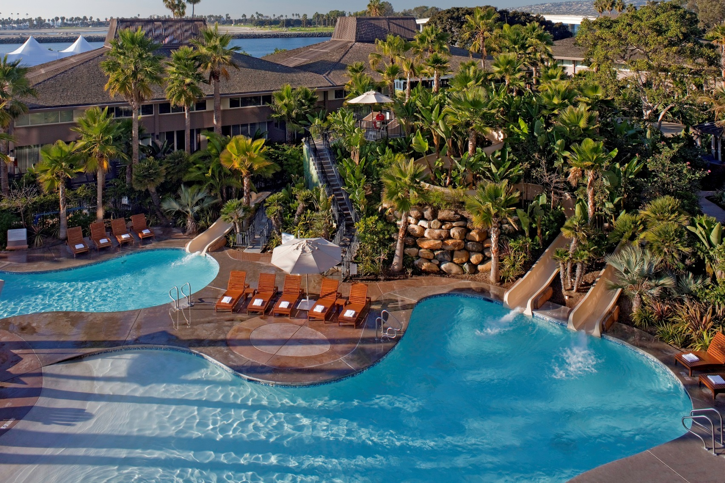

We look forward to
seeing you . . .

At the Hyatt Regency Mission Bay Spa & Marina San Diego, California in June

