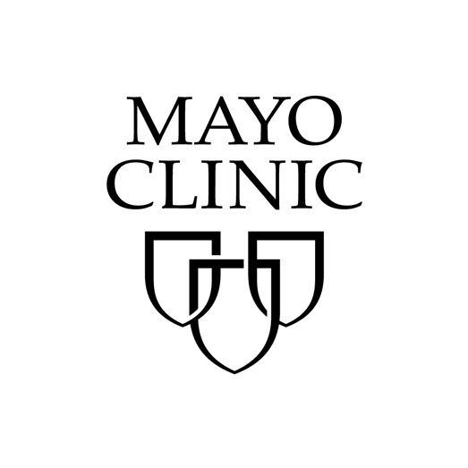
Mayo Clinic School of Continuous Professional Development
200 First Street SW
Rochester, MN 55905

April 2019

Dear Representative:

On behalf of the Mayo Clinic School of Continuous Professional Development, we would like to invite you to exhibit at the upcoming Mayo Clinic Connecting Communities in Emergency Medicine: Current and Upcoming Applications of Care. The course is September 11-13, 2019 at the St. Paul Hotel in St. Paul, Minnesota. We anticipate great interest from commercial companies with products and services of interest to our attendees, and the exhibit space is limited.

The full program schedule will soon be posted to the course website. This course is designed for emergency department providers who are motivated to incorporate the latest advances in care to their own practice setting. Nurses, physicians, pharmacists, nurse practitioners and physician assistants are encouraged to attend and take advantage of this unique opportunity to learn from and meet Mayo Clinic Rochester faculty who are intentionally looking for ways to improve the care of acutely ill and injured adults and children every day. Join us to find ways to add to your day-to-day practice. We expect approximately 100-125 practicing emergency medicine physicians, nurses, nurse practitioners, physician assistants from the region and across the country.

Mayo Clinic, an integrated, not-for-profit group practice, is committed to meeting its responsibility as a national medical education resource and is accredited by the Accreditation Council for Continuing Medical Education to provide continuing medical education for physicians (AMA).

We are inviting you to exhibit at this meeting for a fee of $2,000. If you are interested in exhibiting or would like additional details about this program, return a signed letter of agreement before August 16, 2019. If you have questions about the exhibit, please contact Julie Reed, CME Specialist, by e-mailing reed.julie1@mayo.edu or calling 507-266-2821.

Please return a signed letter of agreement (LOA) to confirm your participation by August 16, 2019. Payment may be completed by sending your check, made payable to Mayo Clinic, to ATTN: Julie Reed – Plummer 2-60, 200 First St SW, Rochester, MN, 55905. Please denote project number 19R06196 on your correspondence. The Mayo Clinic tax ID number is 41-6011702.

Sincerely,

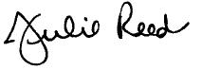

Julie Reed
CME Specialist
reed.julie1@mayo.edu  507-266-2821

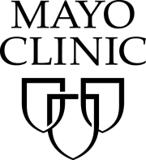
Mayo Clinic School of Continuous Professional Development (MCSCPD)
Exhibitor Agreement
Activity Title | Practical Emergency Medicine: Current and Upcoming Applications of Care
Activity Number | 19R06196
Location | St. Paul Hotel, St. Paul, Minnesota
Dates | September 11-13, 2019

Agreement between: ACCREDITED PROVIDER: Mayo Clinic College of Medicine and Science – MCSCPD AND:
Company Name (Exhibitor)
(as it should appear on printed materials)
Exhibit Contact (if different then exhibit Rep.)
Name(s) of Representative(s) exhibiting:
(Maximum of two representatives allowed per exhibit)
Address
Telephone
Fax
Email
The named exhibitor wishes to exhibit at the above named activity for the amount of |  | $2,000

NOTE: There may be additional charges depending on the meeting location (power, internet access, etc.).
Please list additional requests here: (please note: additional requests may incur additional fees)

TERMS AND CONDITIONS
- EXHIBITOR agrees to abide by ACCME Standards for Commercial Support as stated at www.accme.org: SCS 4.2: “Product-promotion material or product-specific advertisement of any type is prohibited in or during CME activities. The juxtaposition of editorial and advertising material on the same products or subjects must be avoided. Live (staffed exhibits, presentations) or enduring (printed or electronic advertisements) promotional activities must be kept separate from CME.” “For live, face-to-face CME, advertisements and promotional materials cannot be displayed or distributed in the educational space immediately before, during or after a CME activity. Providers cannot allow representatives of Commercial Interests to engage in sales or promotional activities while in the space or place of the CME activity.”
- EXHIBITOR may only distribute educational promotional materials at their exhibit space. Distribution of non-educational items (pens, notepads, etc.), pharmaceuticals or product samples is prohibited.
- All exhibit fees associated with this activity will be given with the full knowledge of the PROVIDER. No additional payments, goods, services or events will be provided to the course director(s), planning committee members, faculty, joint provider, or any other party involved with the activity.
- Completion of this agreement represents a commitment and EXHIBITOR is obligated to provide full payment of all amounts due under this agreement by the ACTIVITY DATE unless otherwise agreed upon by the PROVIDER. PROVIDER reserves the right to refuse exhibit space to EXHIBITOR in the event of nonpayment or Code of Conduct violation.
- If this agreement is cancelled by either party forty-five (45) days or more in advance of the Activity Date, PROVIDER will refund the Exhibit Fee less a $300 processing fee. If this agreement is cancelled by EXHIBITOR less than forty-five (45) days in advance of the Activity Date, the total amount due under this Agreement shall be immediately due and payable to PROVIDER.
- PROVIDER agrees to provide exhibit space and may acknowledge EXHIBITOR in activity announcements. PROVIDER reserves the right to assign exhibit space or relocate exhibits at its discretion.

Note: All exhibitors must be approved by MCSCPD and this agreement is not binding until both parties have signed. MCSCPD maintains the right to refuse any exhibitor.
By signing below, I agree to the “Terms and Conditions” outlined on Page 1 of this Exhibitor Agreement (including ACCME Standards for Commercial Support):

The person signing below is authorized to enter into this agreement:
Exhibitor Representative Name | Signature | Date
Mayo Clinic Representative Name | Signature | Date

PAYMENT INFORMATION
Please indicate your method of payment:

PROVIDER Federal Tax ID number is 41-6011702.
Please remit check payable to: Mayo Clinic- Mayo Clinic School of CPD. Please identify name of course on the check stub.

☐ Check | ☐ Credit Card or Wire Transfer
Make payable to:  Mayo Clinic  Mayo Clinic School of Continuous Professional Development  200 First St SW, Plummer 2-60  Rochester, MN 55905  Please identify Emergency Medicine 19R06196 on the check. | For payment by credit card or wire transfer, please call the MCSCPD Registrar at 800-323-2688  Do not send credit card information via email or fax.

Complete and return this form along with your payment made to Mayo Clinic,
Federal Tax ID# 41-6011702 before August 16, 2019 to:
Kathy Fuqua, EAC
200 First St SW, Plummer 2-60
Rochester, MN 55905
T: 507-266-9815 E: Fuqua.kathy@mayo.edu

