Physician Assistant Board Review A Comprehensive Review
for PAs and NPs

Mayo Clinic, Rochester, MN
Tuesday-Friday, August 7-10, 2018

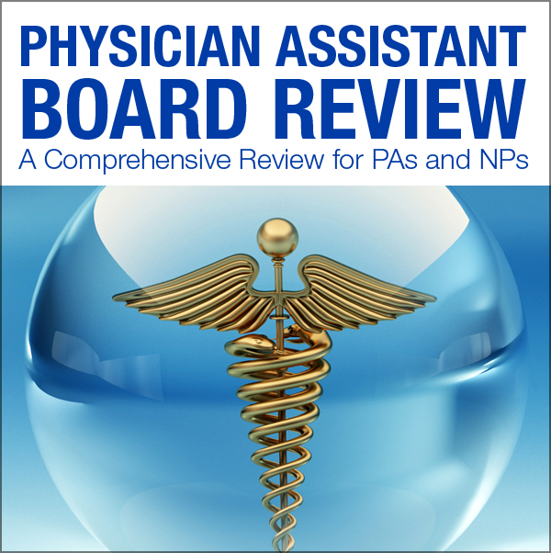

Dear Potential Exhibitor,
On behalf of Mayo Clinic and the Mayo Clinic School of Continuous Professional Development, we are pleased to announce the Physician Assistant Board Review course, which will be held August 7-10, 2018, at the Mayo Clinic Campus in the Siebens Medical Education Building in Rochester, Minnesota. We are very excited to have a course tailored the course to Physician Assistant and Nurse Practitioner needs.

The 2018 Mayo Clinic Physician Assistant Board Review course is a comprehensive review designed to not only help with Initial and Recertification Examinations, but also to provide a relevant review for daily practice. This course has top Mayo Clinic faculty and unparalleled content and experience proven learning techniques to enhance learning and recall. You may find additional course details on the course website: https://ce.mayo.edu/paboardreview2018

Mayo Clinic recognizes these types of educational programs would not be possible without your support. We invite you to participate at this educational activity with an exhibit in the amount of $1,500.00. This fee is for the exhibit space only. Industry exhibitors are provided a draped table with two chairs.

In support of ACCME guidelines exhibitors will be located in a separate area from the educational activity. Exhibit space is limited and located near the food and beverage area for optimal contact during breakfast and breaks. If you are interested in exhibiting at our course, please complete and return the provided Exhibitor Agreement form and payment before August 1, 2018. This agreement may be substituted with your company’s standard Letter of Agreement form. Please make payment payable to Mayo Clinic and send payment to my attention at the address below. For your convenience, our Federal tax identification number is 41-6011702.

We look forward to the success of our Physician Assistant Board Review course and hope you will be able to join us this coming August. If you have any questions or your company requires completion of a web-based application, please feel free to contact me.

Sincerely,
Kathy Fuqua
Education Administration Coordinator
Mayo School of Continuous Professional Development
200 First Street SW
Plummer 2-60
Rochester, MN 55905
fuqua.kathy@mayo.edu
Phone: 507-266-9815

Exhibitor Information

Overview
The 2018 Mayo Clinic Physician Assistant Board Review course is a comprehensive review designed to not only help with Initial and Recertification Examinations, but also to provide a relevant review for daily practice. This course has top Mayo Clinic faculty and unparalleled content and experience proven learning techniques to enhance learning and recall. You may find additional course details on the course website: https://ce.mayo.edu/paboardreview2018

Audience
We expect 80 attendees at the Physician Assistant Board Review. This course was designed with Nurse Practitioners and Physician Assistants in mind.

Dates
Tuesday-Friday, August 7-10, 2018

Course Highlights
- Intensive high-yield review
- Aligned to the PANCE/PANRE blueprint
- Course app with presentations and note- taking functionality
- Daily exam prep practice questions
- 34.0 hours of AAPA Category 1 CME credit
- 34.75 ANCC nursing contact hours
- Approximately 11.75 designated pharmacology content
- 15.0 AAPA Category 1 Self-Assessment CME Credits
- Additional "Acid Base" and "Electrolyte" Modules
- Access to all presentation recordings for one year
- Optional Mayo Clinic tour-August 7th
• Welcome Netwoion
Website
https://ce.mayo.edu/paboardreview2018
W-9
Location
Mayo Clinic
Siebens Medical Education Building
2nd Floor, Leighton Auditorium
Price
$1,500, exhibit fee includes one 6 foot table and two chairs. Exhibitors are invited to participate in all food and beverage events, which include breakfast, lunch and refreshment breaks. Up to two (2) company representatives may attend.

Attendee List
Exhibitors will be provided and attendee list with the following attendee information:
  - First/Last Name
  - Credentials
  - City, State
Exhibit Area
Exhibitors will be located in the refreshment area.

Set-Up
Set up will be Monday, August 6th between 3:00–7:00 p.m.
Hours
Tuesday, August 7, 2018, 6:30 a.m. to Friday, August 10, 2018, 5:00 p.m.

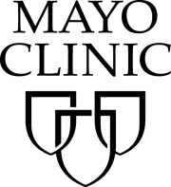
Mayo School of Continuous Professional Development (MSCPD)
Exhibitor Agreement
Activity Title | Physician Assistant Board Review: A comprehensive review for Physician Assistants and Nurse Practitioners 2018
Activity Number | 18R05769
Location | Mayo Clinic, Leighton Auditorium, Siebens Medical Education Building, Rochester, MN
Dates | Tuesday-Friday, August 7-10, 2018

Agreement between: ACCREDITED PROVIDER: Mayo Clinic College of Medicine – MSCPD AND:
Company Name (Exhibitor)
(as it should appear on printed materials)
Exhibit Contact (if different then exhibit Rep.)
Name(s) of Representative(s) exhibiting:
(Maximum of two representatives allowed per exhibit)
Address
Telephone
Fax
Email
Additional Needs, i.e. power, internet, etc.
The named exhibitor wishes to exhibit at the above named activity for the amount of |  | $1,500.00

TERMS AND CONDITIONS
- EXHIBITOR agrees to abide by ACCME Standards for Commercial Support as stated at www.accme.org: SCS 4.2: “Product-promotion material or product-specific advertisement of any type is prohibited in or during CME activities. The juxtaposition of editorial and advertising material on the same products or subjects must be avoided. Live (staffed exhibits, presentations) or enduring (printed or electronic advertisements) promotional activities must be kept separate from CME.” “For live, face-to-face CME, advertisements and promotional materials cannot be displayed or distributed in the educational space immediately before, during or after a CME activity. Providers cannot allow representatives of Commercial Interests to engage in sales or promotional activities while in the space or place of the CME activity.”
- EXHIBITOR may only distribute educational promotional materials at their exhibit space. Distribution of non-educational items (pens, notepads, etc.), pharmaceuticals or product samples is prohibited.
- All exhibit fees associated with this activity will be given with the full knowledge of the PROVIDER. No additional payments, goods, services or events will be provided to the course director(s), planning committee members, faculty, joint provider, or any other party involved with the activity.
- Completion of this agreement represents a commitment and payment is due and collectible by the ACTIVITY DATE unless otherwise agreed upon by the PROVIDER. PROVIDER reserves the right to refuse exhibit space to EXHIBITOR in the event of nonpayment or Code of Conduct violation.
- PROVIDER agrees to provide exhibit space and may acknowledge EXHIBITOR in activity announcements. PROVIDER reserves the right to assign exhibit space or relocate exhibits at its discretion.

By signing below, I agree to the “Terms and Conditions” outlined on Page 1 of this Exhibitor Agreement (including ACCME Standards for Commercial Support):

The person signing below is authorized to enter into this agreement:
Exhibitor Representative Name | Signature | Date
Mayo Clinic Representative Name | Signature | Date

PAYMENT INFORMATION
Please indicate your method of payment:

PROVIDER Federal Tax ID number is 41-6011702.
Please remit check payable to: Mayo Clinic- Mayo School of CPD. Please identify name of course on the check stub.

☐ Check | ☐ Credit Card or Wire Transfer
Make payable to:  Mayo Clinic  Mayo Clinic School of Continuous Professional Development  200 First St SW, Plummer 2-60  Rochester, MN 55905  Please identify PABR on the check. | For payment by credit card or wire transfer, please call the MSCPD Registrar at 800-323-2688  Do not send credit card information via email or fax.

Complete and return this form along with your payment made to Mayo Clinic,
Federal Tax ID# 41-6011702 before August 1, 2018 to:
Kathy Fuqua, EAC
200 First St SW, Plummer 2-60
Rochester, MN 55905
T: 507-266-9815 F: 507-538-7234 E: Fuqua.kathy@mayo.edu

