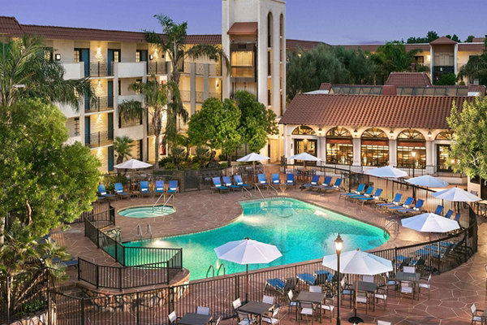 March 22-24, 2018
Mayo Clinic School of Continuous Professional Development
3rd Annual SKIN: Practical Dermatology for the Generalist
EXHIBITOR PROSPECTUS
Embassy Suites Scottsdale Resort


3rd Annual SKIN: Practical
Dermatology for the Generalist
Acte Care of the Complex Hospitalized Patient
for NPs & PAs

CONTENTS
Welcome 3
Dates 4
Planning Committee
& Key Contacts 4
Conference Highlights 5
Exhibitor Information 6
Sponsorship Opportunities 6
Exhibit Hall Floor Plan 8
Rules and Regulations 9
Hotel Accommodations 10



Welcome

Dear Exhibitors,

On behalf of the Mayo Clinic School of Continuous Professional Development, I am pleased to invite you to participate in the 3rd Annual Mayo Clinic SKIN: Practical Dermatology for the Generalist that will take place on March 22-24, 2018 at the Embassy Suites by Hilton Scottsdale Resort in Scottsdale, Arizona.

SKIN: Practical Dermatology for the Generalist is the 3rd Mayo Clinic course taught by expert dermatologists from the three Mayo Clinic national practices in Minnesota, Florida and Arizona with the goal of teaching practical dermatology to the non-dermatologist. The course will consist of interactive lectures covering multiple aspects of dermatology including management of moles, skin infections, cancers, rashes, lumps and bumps, and simple dermatologic procedures. The information presented will be relevant to a broad range of non-dermatologists and primary care providers, including physician assistants, general practitioners, internists and nurse practitioners. It will allow these practitioners to feel comfortable caring for patients with skin conditions.

Course Highlights

- Approximately 5.75 hours of pharmacology content
• Getting to Brass Tacks on Nails
• What Do You Mean "Dermatitis"?
• The Itchy Patient
• Acne Tips and Pearls
• Fungus Among Us
• Rashes You Get on Vacation
• Common Rashes in Children
• When It Isn’t Dermatitis
• Is This a Drug Rash?
• Biopsies and Other Office Procedures

We anticipate 300 attendees at the program. We have 20 faculty members who are practicing Dermatologists. To view the entire program and additional information please go to https://ce.mayo.edu/skin2018
Sincerely,
CME Course Co-Directors/Guest Course Director

Christopher J. Arpey, M.D. Alison J. Bruce, M.B., Ch.B. | Steven A. Nelson, M.D. | Michael J. Hovan, M.D.
Professor of Dermatology Associate Professor of Dermatology | Assistant Professor of Dermatology | Assistant Professor of Family Medicine
Dermatology Dermatology Dermatology |  | Family Medicine

Dates and Location

Meeting Dates:
Thursday, March 22, 2018- Saturday, March 24, 2018
Meeting Location:

Embassy Suites Scottsdale Resort
5001 N. Scottsdale Road
Scottsdale, AZ 85250
Tel. +1 480-949-1414
http://embassysuites3.hilton.com/en/hotels/arizona/embassy-suites-by-hilton-scottsdale-resort-SCTESES/index.html
Course Website:
https://ce.mayo.edu/skin2018

Committee Members and Key Contacts
Committee Members |  |  | Key Contacts
Christopher J. Arpey, M.D.  Professor of Dermatology, College of Medicine  Dermatology | Alison J. Bruce, M.B., Ch.B.  Associate Professor of Dermatology, College of Medicine  Dermatology | Steven A. Nelson, M.D.  Assistant Professor of Dermatology, College of Medicine  Dermatology | Vicki R. Meyer, B.S.  CME Specialist  Ph: 507-266-7992  Meyer.vicki@mayo.edu
Michael J. Hovan, M.D.  Assistant Professor of Family Medicine, College of Medicine  Family Medicine | Lynne E. Hulvey, M.S., R.N.  Dermatology | Nancy Slavin  Dermatology | Kathy Fuqua  CME Education Specialist  Ph: 507-266-9815  Fuqua.kathy@mayo.edu

Conference Highlights
Topics and speakers are carefully chosen to provide quality, practical and evidence-based workshops and plenary sessions.

Presentation Topics for 2018 include:

- Talk the Talk: Dermatology Lingo
- Actinic Keratoses - Pearls on Precancers
- Clinical to Dermoscopic: Evaluation of
Melanocytic Lesions
- Clinical to Dermoscopic: Evaluation of
Nonmelanocytic Lesions
- Clues to Help the Dermatopathologist
- Biopsies and Other Office Procedures
- Skin Cancer Treatment: Pitfalls
- Warts and Molluscum
- Sun Protection
- Is This a Drug Rash?
- A Mouthful of Problems
- What's Topical in Topicals
- What Do You Mean "Dermatitis"?
- Is Patch Testing Really Necessary?
Empiric Allergen Avoidance Made Easy
- Papulosquamous Disorders:
When It's Not Dermatitis
- Rashes You Get on Vacation
- Acne Tips and Pearls
- Rashes That Kill
- Cases Gone Wrong
- Clues to Systemic Diseases
- Unusual Symptoms with Nowhere to Go
- Latest and Greatest in Atopic Dermatitis
- Canker Sores
- Getting to Brass Tacks on Nails
- Common Rashes in Children
- Help! My Hair is Falling Out
- Urticaria and Hives: What's the Buzz?
- What's Happening Down Below?
- The Dreaded Facial Rash
- Moisturizers and Other OTC Treatments
- Fungus Among Us
- The Itchy Patient

Why Exhibit?
Technical and educational exhibits provide a professional and educational environment in which NPs, PAs, APNs, RNs, and physicians can receive demonstrations, view products and services and discuss the clinical and surgical uses of these products and services, including how they may improve the quality of care and the management of the medical/surgical practice. Additionally, the exhibits enhance the educational content of the meeting helping to provide quality continuing medical education.

Benefits:
  - Interact face-to-face with influential decision makers in the field of neuroscience and oncology
  - Build visibility for your company in a competitive marketplace
  - Expand your customer base and strengthen existing customer relationships
  - Introduce new products and services
  - Additional advertisement opportunities to expand reach and further socialize with attendees

General Exhibitor Information Exhibit Hours Schedule
EXHIBIT CONTACT: Wednesday, March 21, 2018
Exhibitor Set-Up 5:00 PM – 7:00 PM
Kathy Fuqua

Mayo Clinic School of Continuous Professional Development Thursday, March 22, 2018 7:00 a.m. – 3:15 p.m.
Plummer 2-60, 200 1st ST SW, Rochester, MN 55905 Friday, March 23, 2018 7:00 a.m. – 3:15 p.m.
Ph: 507-266-9185 Saturday, March 24, 2018 7:00 a.m. – 12:45 p.m.
Fax: 507-538-7234 Exhibitor Tear Down 12:45 p.m. – 1:00 p.m.

Booth Fee: $1,500
  - (1) 8’ table (2) chairs
  - Location preference
  - General maintenance of the common areas of the exhibit hall
  - Access to networking opportunities throughout the conference

Exhibitor Assignments
Every effort will be made to give exhibitors their first choice of location. In case of conflicting requests, priority will be determined on the basis of: 1) Amount of space requested, 2) Date the application was received by MCSCPD, 3) Special needs of the exhibitors. Booth assignments will be made when full payment is received and these SOLD booths will be updated on the Exhibitor Prospectus.

Advertisement Opportunities
This course offers a quality selection of marketing and advertising opportunities. These are designed to help companies further engage, network and connect with attendees during the annual conference. Mayo Clinic staff are available to help maximize exposure through additional advertisement opportunities.

Don’t see what you are looking for? Contact us and we would be happy to discuss additional advertisement opportunities with you.
Additional Advertisement Opportunities

Hotel Key Card- $5,000.00 (Exclusive) - Personalize hotel guest room keys with your company’s logo or product promotion for immediate exposure to attendees. Use this as a great way to introduce yourselves to our attendees upon checking into the host hotel. Include your booth number to remind them where you’ll be throughout the conference. (Artwork to be provided by sponsoring company by March 1, 2018)

Mobile Charging Stations- $5,000.00 each (3 available) - Charging stations will provide attendees an area to charge their mobile device or use their iPad or laptop. Your corporate logo or product on the charging stations will recognize your company’s sponsorship and will include your booth location.

Internet- $5,000.00 (Exclusive) - Help attendees stay connected with their office and home while away at the SKIN: Practical Dermatology for the Generalist course. The supporter will be recognized throughout the meeting in signage and electronic communications.

Attendee lanyards logo - Personalize lanyards with your company’s logo or product promotion for immediate exposure to attendees.
Conference Bags- $2,500 - Personalize conference bags with your company’s logo or product promotion for immediate exposure to attendees. Use this as a great way to introduce yourselves to our attendees upon checking into the course. Include your booth number to remind them where you’ll be throughout the conference. (Artwork to be provided by sponsoring company)

Conference Bag Inserts- $1,500.00 - Conference bag inserts are a great opportunity to invite attendees to your booth, announce your booth participation or conference- related event. Your company will provide 400 copies of the flyer or advertisement (no larger than 8 ½ x 11, no more than one page) and MCSCPD will stuff them into the official conference bags. Artwork is subject to MCSCPD approval.

Platinum Sponsorship A (exclusive)- $10,000
Hotel key card logo - Personalize hotel guest room keys with your company’s logo or product promotion for immediate exposure to attendees.
Conference bag logo - Personalize conference bags with your company’s logo or product promotion for immediate exposure to attendees.
Conference bag inserts - Your company will provide 400 copies of the flyer or advertisement (no larger than 8 ½ x 11, no more than one page) and MCSCPD will stuff them into the official conference bags.
Exhibitor Table

Platinum Sponsorship B (exclusive) - $10,000
Attendee lanyards logo - Personalize lanyards with your company’s logo or product promotion for immediate exposure to attendees.
Conference bag logo - Personalize conference bags with your company’s logo or product promotion for immediate exposure to attendees.
Conference bag inserts - Your company will provide 400 copies of the flyer or advertisement (no larger than 8 ½ x 11, no more than one page) and MCSCPD will stuff them into the official conference bags.
Exhibitor Table

Platinum Sponsorship B (exclusive) - $10,000
Internet- Sponsor the wireless internet access in the meeting space
Conference bag logo - Personalize conference bags with your company’s logo or product promotion for immediate exposure to attendees.
Conference bag inserts - Your company will provide 400 copies of the flyer or advertisement (no larger than 8 ½ x 11, no more than one page) and MCSCPD will stuff them into the official conference bags.
Exhibitor Table

Gold Sponsorship - $5,000
Conference bag logo - Personalize conference bags with your company’s logo or product promotion for immediate exposure to attendees.
Conference bag inserts - Your company will provide 400 copies of the flyer or advertisement (no larger than 8 ½ x 11, no more than one page) and MCSCPD will stuff them into the official conference bags.
Exhibitor Table

Silver Sponsorship - $3,000
Conference bag inserts - Your company will provide 400 copies of the flyer or advertisement (no larger than 8 ½ x 11, no more than one page) and MCSCPD will stuff them into the official conference bags.
Exhibitor Table

Exhibitor Floorplan

Rules and Regulations
In applying for exhibit space, exhibitors agree to abide by the following regulations:

Exhibit Regulations:
  - Each exhibitor is responsible for compliance with the Americans with Disabilities Act (ADA) within its booth and assigned space.
  - Attire of exhibit personnel should be consistent with the professional atmosphere of the course.
  - Demonstrations by exhibitors may not interfere with normal traffic flow nor infringe on neighboring exhibits. Demonstrations are not permitted outside of the exhibitor’s assigned booth space.
  - Canvassing or distribution of advertising material by an exhibitor is not permitted outside of the exhibitor’s booth space.
  - Canvassing or marketing of any products or services in any part of the exhibit hall or meeting rooms by anyone representing a non- exhibiting firm is strictly prohibited.
  - Subletting of exhibit space is not permitted. Sharing of exhibit space is not permitted unless it is within divisions of the same company.
  - It is the responsibility of the exhibitor to have all licenses, permits, and/or registrations required by the venue, city, municipality and/or state. The exhibitor is responsible for compliance with all applicable tax laws.

CME Guidelines Related to Educational Grants, Exhibit Space and Promotional Activities:
In compliance with ACCME Standards for Commercial Support, arrangements for commercial exhibits or advertisements cannot influence or interfere with the presentation, nor can they be a condition of the provision of commercial support for CME activities.

  - Exhibit and other promotional fees shall be separate and distinct from educational grants/commercial support.
  - All exhibitors must be in a room or area separate from the education and the exhibits must not interfere or in any way compete with the learning experience prior to, during, or immediately after the activity.
  - Company representatives must refrain from holding any commercial discussions in the educational classroom. All promotional activities including interviews, demonstrations, and the distribution of literature or samples must be made within the exhibitor’s space. Canvassing or distributing promotion materials outside the exhibitor’s rented exhibit space is not permitted.
  - Commercial interest representatives may attend CME activities for the sole purpose of the representatives’ own education. However, they may not engage in sales or marketing activities while in the educational classroom.

Liability:
  - Neither Mayo Clinic School of Continuous Professional Development nor the Embassy Suites by Embassy Suites by Hilton Scottsdale Resort, the employees thereof, nor their representatives, nor any member of the Conference Committee shall be responsible for injury, loss, or damage that may occur to the Exhibitor or his property from any cause whatsoever, prior to, during, or subsequent to the period of the Exhibit. The Exhibitor agrees to indemnify, the Mayo Clinic Continuous Professional Development and the Embassy Suites by Hilton Scottsdale Resort and their employees, volunteers, and committees from any and all claims for loss, damage, or injury. Exhibitors are encouraged to insure themselves against property loss or damage, and against both general and personal liability.
  - Exhibitor understands and agrees that, for the safety of conference attendees, Exhibitor shall not perform any procedures on or provide any services to conference attendees that are either invasive or are customarily performed in a practitioner’s office.

Hotel Accommodations
The Embassy Suites by Hilton Scottsdale Resort is offering a discounted rate of $249 (limited number available). Please identify yourself as a participant of the Mayo Clinic Dermatology course when making your reservation. Overlooking Camelback Mountain in the heart of Scottsdale, Embassy Suites by Hilton Scottsdale Resort is just minutes from championship golf courses, spa facilities, shopping, dining, art galleries, MLB Spring Training and outdoor recreation. Our recently renovated Scottsdale hotel is only 15 miles to downtown Phoenix, Talking Stick Arena and Chase Field, and offers convenient freeway access to the University of Phoenix Stadium and the Gila River Arena.
Amenities include:

- High speed wireless internet is included in the guest room rate
- Access to fitness center at no charge
- Complimentary hot made to order breakfast daily
- Complimentary 2 hour reception each night 5:30 pm-7:30 pm

EARLY RESERVATIONS ARE STRONGLY RECOMMENDED.
Click here to reserve your room.

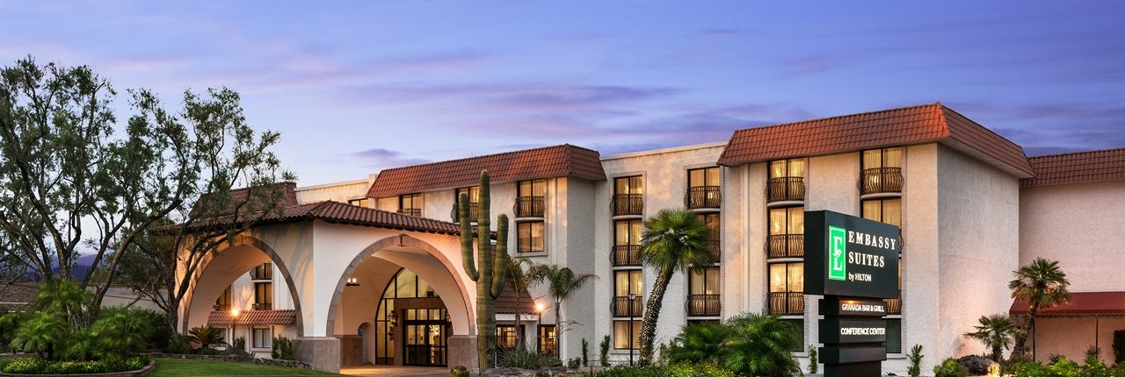
We look forward to seeing you . . .
At the Embassy Suites Scottsdale Resort in Scottsdale, Arizona in March

