2nd Annual
SKIN: Practical Dermatology
for the Generalist

Lowes Portofino Bay Hotel, Orlando, FL
Friday-Saturday, April 7-8, 2017

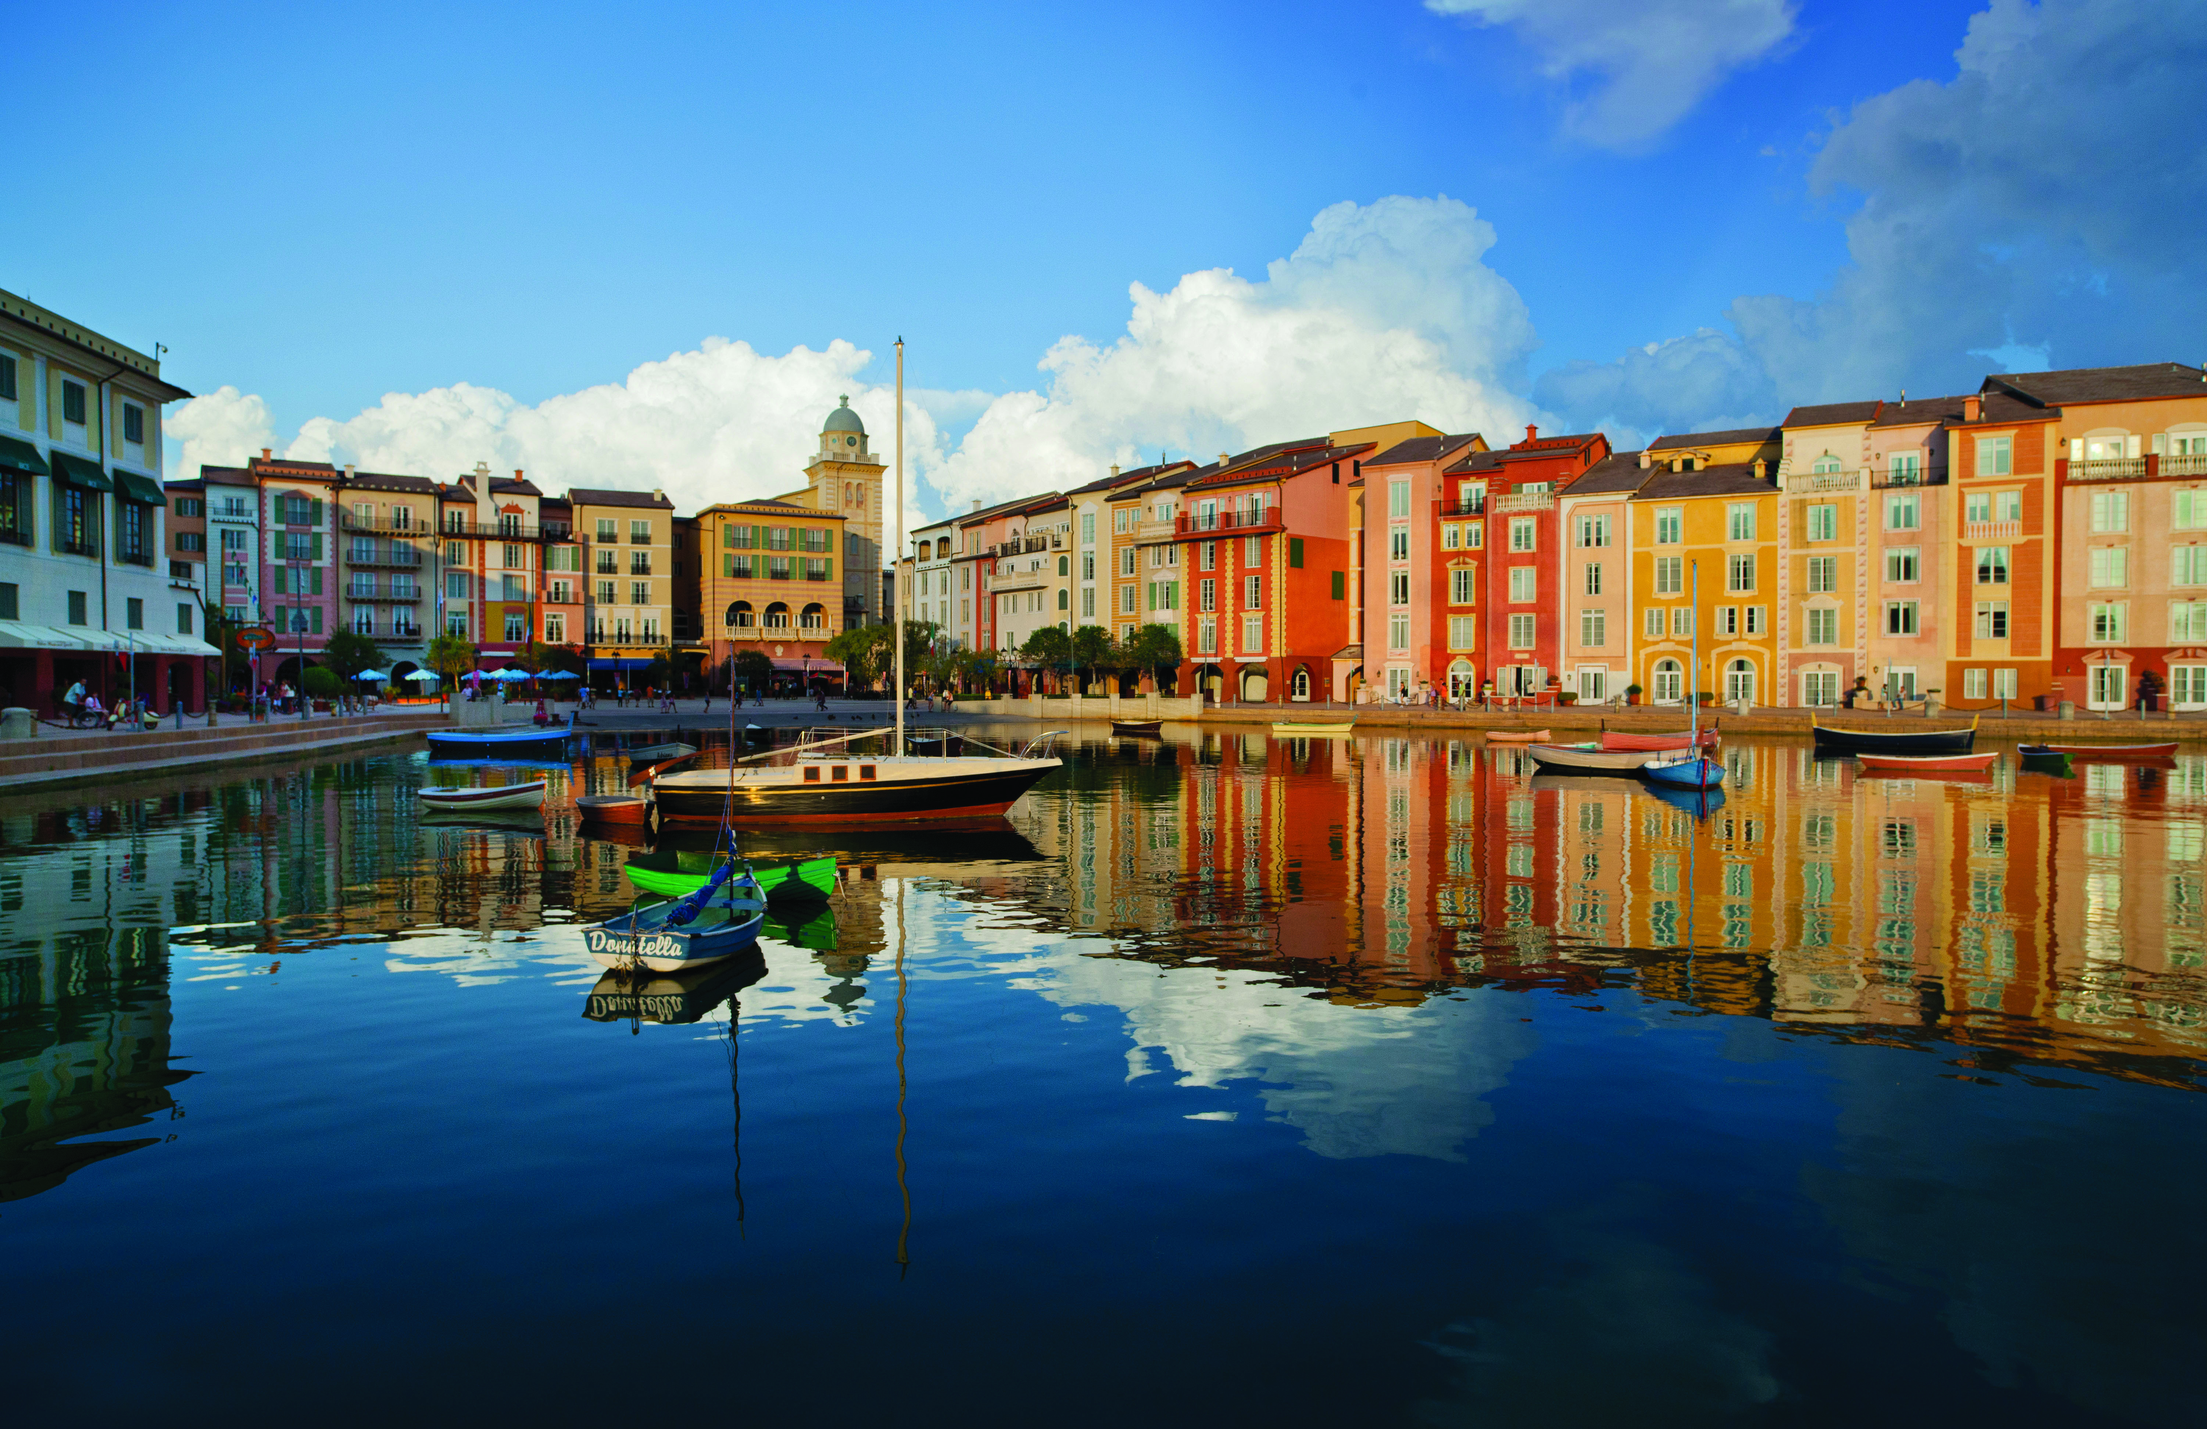

Dear Potential Exhibitor,

On behalf of course directors Christopher J. Arpey, M.D., Alison J. Bruce, M.B., Ch.B., Steven A. Nelson, M.D., and the Mayo School of Continuous Professional Development, we are pleased to announce our upcoming 2nd Annual SKIN: Practical Dermatology for the Generalist, to be held April 7-8, 2017, at the Lowes Portofino Bay Hotel in Orlando, Florida.

The 2nd Annual SKIN: Practical Dermatology for the Generalist is taught by expert dermatologists from the three Mayo Clinic national practices in Minnesota, Florida and Arizona with the goal of teaching practical dermatology to the non‐dermatologist. Last year we sold out with 275 attendees and hopefully anticipate the same at this year’s course. Additional course details can be found on the course web site as they become available: https://ce.mayo.edu/node/20164

Mayo Clinic recognizes these types of educational programs would not be possible without your support. We invite you to participate at this educational activity with an exhibit in the amount of $2,000. This fee is for the exhibit space only. Industry exhibitors are provided a draped table with two chairs. In support of ACCME guidelines, exhibitors will be located in a separate area from the educational activity. Exhibit space is limited and located near the food and beverage area for optimal contact during breakfast, breaks, and lunch.

To exhibit at this course:
- Complete and return the provided Exhibitor Agreement form. This agreement may be substituted with your company’s standard Letter of Agreement form.
- Submit payment before April 1, 2017. Please make payment payable to Mayo Clinic and send payment to my attention at the address below. For your convenience, our Federal tax identification number is 41-6011702.

We look forward to the success of the SKIN: Practical Dermatology for the Generalist course and hope you will be able to join us in Orlando, Florida in April. If you have any questions or your company requires completion of a web-based application, please feel free to contact me.

Sincerely,

Kathy Fuqua
Education Administration Coordinator
Mayo School of Continuous Professional Development
200 First Street SW
Rochester, MN 55905
Fuqua.kathy@mayo.edu
Phone: 507-266-9815
Exhibitor Information

Overview
The 2nd Annual SKIN: Practical Dermatology for the Generalist is taught by expert dermatologists from the three Mayo Clinic national practices in Minnesota, Florida and Arizona with the goal of teaching practical dermatology to the non‐dermatologist. The course will consist of interactive lectures covering multiple aspects of dermatology including management of moles, skin infections, cancers, rashes, lumps and bumps, and simple dermatologic procedures. The information presented will be relevant to a broad range of non‐dermatologists and primary care providers, including physician assistants, generalists, internists, and nurse practitioners; it will allow these practitioners to feel comfortable caring for patients with skin conditions.

Audience
We expect 300 attendees at the 2nd Annual SKIN: Practical Dermatology for the Generalist. This course was designed with MDs, PAs, NPs, Advance Practice Nurses, RNs in general practice.

Dates
Friday-Saturday
April 7-8, 2017

Course Highlights
• Approximately 5 hours of pharmacology content.
• Bread & Butter Dermatology
• What’s This on My Skin?
• The Itchy Patient
• Acne is Still a Problem
• Fungus Among Us
• Common Rashes in Children
• The Changing Mole
• When It Isn’t Dermatitis
• Tricks to Learn from the Dermatologist
• Easy Office Procedures

Website

https://ce.mayo.edu/node/20164

Location
Lowes Portofino Bay Hotel
5601 Universal Boulevard
Orlando, FL 32819
Price
$2,000, exhibit fee includes one 6 foot table and two chairs. Exhibitors are invited to participate in all food and beverage events, which include breakfast, lunch and refreshment breaks.
Exhibit Area
Exhibitors will be placed in the Ballroom Foyer, located just outside the main meeting room with the refreshments.

Set-Up
Set up will be Thursday, April 6th between 5:00–8:30 p.m.
Hours
Friday, April 7, 7:00 a.m. through Saturday, April 8, 2017, 6:00 p.m.

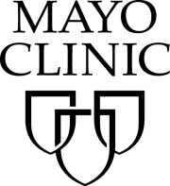
Mayo School of Continuous Professional Development (MSCPD)
Exhibitor Agreement
Activity Title | SKIN: Practical Dermatology for the Generalist
Activity Number | 17R04775
Location | Loews Portofino Bay Hotel, Orlando, Florida
Dates | April 7-8, 2017

Agreement between: ACCREDITED PROVIDER: Mayo Clinic College of Medicine – MSCPD AND:
Company Name (Exhibitor)
(as it should appear on printed materials)
Exhibit Contact (if different then exhibit Rep.)
Name(s) of Representative(s) exhibiting:
(Maximum of two representatives allowed per exhibit)
Address
Telephone
Fax
Email
The named exhibitor wishes to exhibit at the above named activity for the amount of |  | $2,000

TERMS AND CONDITIONS
- EXHIBITOR agrees to abide by ACCME Standards for Commercial Support as stated at www.accme.org: SCS 4.2: “Product-promotion material or product-specific advertisement of any type is prohibited in or during CME activities. The juxtaposition of editorial and advertising material on the same products or subjects must be avoided. Live (staffed exhibits, presentations) or enduring (printed or electronic advertisements) promotional activities must be kept separate from CME.” “For live, face-to-face CME, advertisements and promotional materials cannot be displayed or distributed in the educational space immediately before, during or after a CME activity. Providers cannot allow representatives of Commercial Interests to engage in sales or promotional activities while in the space or place of the CME activity.”
- EXHIBITOR may only distribute educational promotional materials at their exhibit space. Distribution of non-educational items (pens, notepads, etc.), pharmaceuticals or product samples is prohibited.
- All exhibit fees associated with this activity will be given with the full knowledge of the PROVIDER. No additional payments, goods, services or events will be provided to the course director(s), planning committee members, faculty, joint provider, or any other party involved with the activity.
- Completion of this agreement represents a commitment and payment is due and collectible by the ACTIVITY DATE unless otherwise agreed upon by the PROVIDER. PROVIDER reserves the right to refuse exhibit space to EXHIBITOR in the event of nonpayment or Code of Conduct violation.
- PROVIDER agrees to provide exhibit space and may acknowledge EXHIBITOR in activity announcements. PROVIDER reserves the right to assign exhibit space or relocate exhibits at its discretion.

By signing below, I agree to the “Terms and Conditions” outlined on Page 1 of this Exhibitor Agreement (including ACCME Standards for Commercial Support):

The person signing below is authorized to enter into this agreement:
Exhibitor Representative Name | Signature | Date
Mayo Clinic Representative Name | Signature | Date

PAYMENT INFORMATION
Please indicate your method of payment:

PROVIDER Federal Tax ID number is 41-6011702.
Please remit check payable to: Mayo Clinic- Mayo School of CPD. Please identify name of course on the check stub.

☐ Check | ☐ Credit Card or Wire Transfer
Make payable to:  Mayo Clinic  Mayo School of Continuous Professional Development  200 First St SW, Plummer 2-60  Rochester, MN 55905  Please identify SKIN on the check. | For payment by credit card or wire transfer, please call the MSCPD Registrar at 800-323-2688  Do not send credit card information via email or fax.

NOTE: There may be additional charges depending on the meeting location (power, internet access, etc).
Please list additional requests here:

Complete and return this form along with your payment made to Mayo Clinic,
Federal Tax ID# 41-6011702 before April 1, 2017 to:
Kathy Fuqua, EAC
200 First St SW, Plummer 2-60
Rochester, MN 55905
T: 507-266-9815 F: 507-538-7234 E: Fuqua.kathy@mayo.edu

