Exhibitor & Sponsorship Prospectus
Endocrine Update 2027
January 31- February 5, 2027
Paradise Island, Bahamas
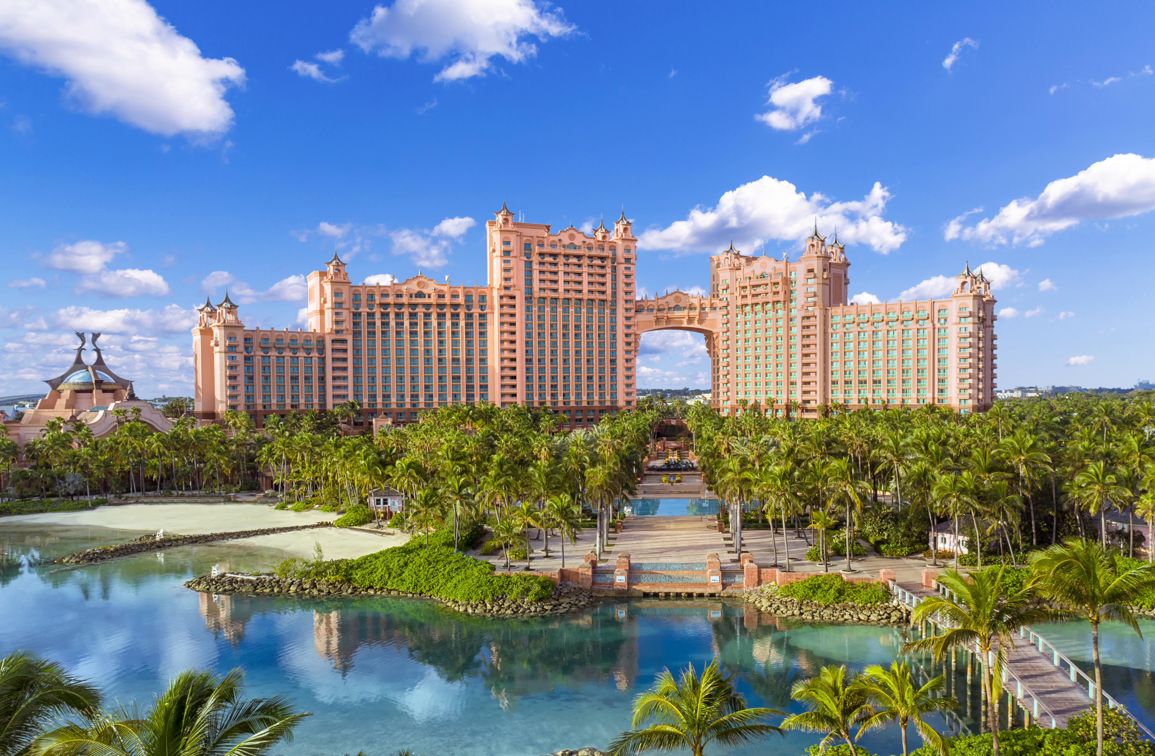
Greetings!
On behalf of the course directors, planning committee, and the Mayo Clinic School of Continuous Professional Development, we are pleased to announce the upcoming Endocrine Update 2027 conference. Please join us February 1 – February 5, 2027, in Paradise Island, Bahamas at the Atlantis Paradise Island.
Designed for endocrinologists and interested primary care providers and surgeons, this course addresses gaps in medical knowledge and barriers in clinical practice to improve the outcomes of patients with endocrine and metabolic disorders. This program will consist of lectures, small groups, and panel discussions formats covering best practices, barriers to optimal patient outcomes, and new approaches to the evaluation and management of complex and common endocrine disorders. In addition, this year’s program will feature optional afternoon workshops on integrating emerging digital technologies into practice. We anticipate over 200 attendees for the course in 2027.
We invite your company to join us along with the world-renowned faculty and support this conference. Based on the level of support you are interested in providing, we can offer various levels of recognition. Companies that support this Mayo Clinic conference are acknowledged in several ways, including the opportunity for an onsite exhibit, signage at the conference, and featured in conference announcements. Ample opportunities are provided during the conference for sponsors and exhibitors to network with attendees and to showcase their products and services. Mayo Clinic recognizes that these types of educational programs would not be possible without your support. We invite you to participate in this educational activity with sponsorship or as an exhibitor. Details are listed below. In support of ACCME guidelines, commercial support will be in a separate area from the educational activity. This event is open to multiple pharmaceutical companies.
If you have any questions, please feel free to contact us.
Sincerely,
Rene Cima, M. Ed.  stiller.rene@mauo.edu  CME Specialist | Jessica DeGeus  DeGeus.Jessica@mayo.edu  Education Administration Coordinator

Sponsorship Opportunities
PLATINUM | GOLD | SILVER
$25,000 | $13,000 | $8,000
Attendee Reception Sponsor  (Exclusive Opportunity)  Company signage and representation at attendee reception | Refreshment Break Sponsor  (Five Available)  Company signage at one of the refreshment breaks | Daily Coffee Sponsor  (Five Available)  Company signage at the coffee stations
Platinum sponsors may opt to support the Attendee Reception or be acknowledged as a General Sponsor of the course. | Gold sponsors may opt to support a Refreshment Break or be acknowledged as a General Sponsor of the course. | Silver sponsors may opt to support Daily Coffee or be acknowledged as a General Sponsor of the course.
Platinum sponsors will receive:  - Three complimentary registrations (No CME credit may be claimed)  - Signage at attendee reception if applicable  - One 6-foot exhibit table for two representatives  - Sponsorship acknowledgement at course through signage and announcements  - Access to networking opportunities throughout the course  - A list of conference attendees on the first day of the conference | Gold sponsors will receive:  - Two complimentary registrations (No CME credit may be claimed)  - Signage near refreshment break on designated day  - One 6-foot exhibit table for two representatives  - Sponsorship acknowledgement at course through signage and announcements  - Access to networking opportunities throughout the course  - A list of conference attendees on the first day of the conference | Silver sponsors will receive:  - One complimentary registration (No CME credit may be claimed)  - Signage near coffee station for one day  - One 6-foot exhibit table for two representatives  - Sponsorship acknowledgement at course through signage and announcements  - Access to networking opportunities throughout the course  - A list of conference attendees on the first day of the conference
Note on Branded Materials:
Sponsors are responsible for designing, printing, and producing their own conference signate, etc. featuring their logo if desired. If not, we shall provide signage according to Mayo Brand standards with the company name printed for learner reference. Please note that all artwork and materials are subject to MCSCPD approval before production and distribution. The Mayo Clinic logo and brand elements may not be used on sponsor produced materials.

Sponsorships range from $7,000 to $25,000 and feature various perks. Please email Jessica DeGeus at DeGeus.Jessica@mayo.edu for more information on alternative or exclusive opportunities.
A signed agreement is required to secure your sponsorship. Click here to secure your sponsorship. Email Jessica DeGeus at DeGeus.Jessica@mayo.edu with questions.

Non-CME Educational Session - Product Theater (limited spots available – reserve early to guarantee your spot)
$35,000 – Lunch
$30,000 – Breakfast
A Non-CME Educational Session or Product Theater provides an opportunity for an organization to speak to attendees and faculty of the course during break time. These sessions may be focused on either a product/device or an educational topic that is relevant to both the course and the company.
The accepted sessions will feature an opportunity to speak on Monday (February 1st), Tuesday (February 2nd), Wednesday (February 3rd), or Thursday (February 4th) after the morning session concludes. This is a Promotional Symposium (Non-CME Event). Mayo Clinic will provide basic food and beverages. Premium food and beverage options are available for an additional fee. Nonaccredited programs such as these are independently developed and directly sponsored by industry and are presented in an educational format that will provide insight into new or controversial developments.
All sessions will receive the following:
- Four complimentary registrations (No CME credit may be claimed)
- One 6-foot exhibit table for two representatives
- Acknowledgement at course through signage and announcements
- Access to networking opportunities throughout the course
- A list of conference attendees on the first day of the conference
The Planning Committee reserves the right to review all submissions before final agreements have been made. Companies are encouraged to speak on educational topics in addition to products. Please note, audiovisual equipment and fees are the responsibility of the industry supporter.
A signed agreement is required to secure your sponsorship. Click here to secure your sponsorship. Email Jessica DeGeus at DeGeus.Jessica@mayo.edu with questions.

Exhibit Booth (limited spots available – reserve early to guarantee your spot)
$4,000
Exhibit tables offer an opportunity for company representatives to engage with attendees and faculty during break times of the course. All exhibits include:
- One 6-foot table for two representatives
- Acknowledgement at course through signage and announcements
- Access to networking opportunities throughout the course
- A list of conference attendees on the first day of the course
Click here to secure your exhibit booth.
A signed agreement is required to secure your exhibit booth as space is limited.
Exhibit Hours
Sunday, January 31 | Set-up (hours TBD)
Monday, February 1 | Breakfast (7:00 am – 7:45 am)  Refreshment break (10:00 am – 10:20 am)  Lunch (12:30 pm – 1:45 pm)  Attendee Reception (5:00 pm – 6:30 pm)
Tuesday, February 2 | Breakfast (7:00 am – 7:45 am)  Refreshment break (10:00 am – 10:20 am)  Lunch (12:30 pm – 1:45 pm)
Wednesday, February 3 | Breakfast (7:00 am – 7:45 am)  Refreshment break (10:45 am – 11:05 am)  Lunch (12:45 pm – 2:00 pm)
Thursday, February 4 | Breakfast (7:00 am – 7:45 am)  Refreshment break (9:30 am – 9:50 am)  Lunch (12:30 pm – 1:45 pm)
Friday, February 5 | Breakfast (7:00 am – 7:45 am)  Refreshment break (10:00 am – 10:20 am)
Tear-Down: All materials must be removed by 1:30 pm on Friday, February 5, 2027.

Travel Information
Atlantis Paradise Island
1 Casino Drive
Paradise Island
Bahamas
To book your accommodations, please use this link. All reservations must be made by Dec 31, 2026.
*The link to the room block is available on the course website.

